Theme of the Past

- What is significant about the following things in the description of the
Ghost of Christmas Past for Scrooge (P.25):
a)The light
b)The fact that it is indistinct and fades in and out of view.
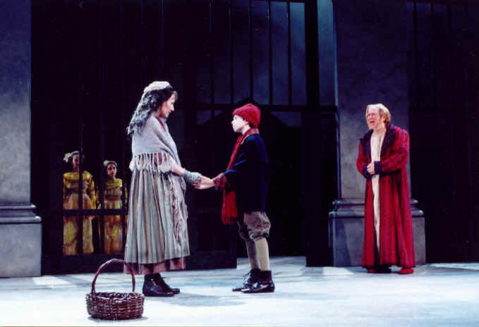
- Find the quote on P.26 that shows what the past can bring –linked to the word ‘thousand’!
- Find the quote at the bottom of P.26 that shows The Ghost of Christmas Past is telling Scrooge off!
- What impact does the vision of his former self alone in the School House (left there for the holidays) have on Scrooge? (P.29)
- What type of character was Scrooge’s sister Fan? How is her introduction a happy memory for Scrooge? (P.29)
- How does the Ghost of Christmas Past make Scrooge guilty about the present via his mention of Fan’s one living relation? (P.30)
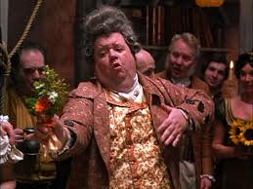

- Write down 3 things about Fezziwig, and why the Ghost shows Scrooge his time as an employee there? (P.31/32)
- What does Scrooge learn from this scene? (P.33)

- The final scene the Ghost shows Scrooge is of his former fiancée Belle –her break-up argument with Scrooge, then Belle a few years later. Summarise what happens in these two episodes and what Scrooge learns he has lost out on (P.34-37)
