Theme of Money and Wealth

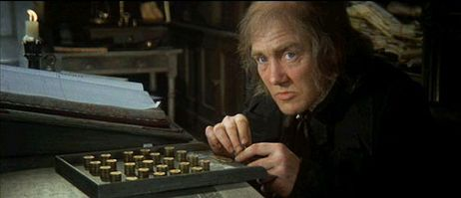

Context
- Think back to your context notes. What did Dickens see as the wealthy people in society’s responsibility?
- What happened to Dickens’ father when he was young which made Dickens appreciate the importance of having enough money to live on?

The Novel
- What does Scrooge do at his former partner, Jacob Marley’s funeral which shows his love of money? (P.7)
- Why is Christmas time a bad one in terms of making money for Scrooge? (Top P.10)
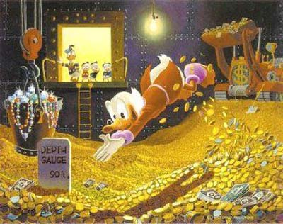
- How much does Scrooge pay Bob Cratchit his employee? (P.11) How do we later discover that this is not very much in the tale?
- Why else does Bob Cratchit’s request at the top of page 14 annoy Scrooge in terms of money?

- How are Marley’s chains a warning to Scrooge about his love of money? (P.19)
- Find the quote that shows what Marley bitterly regrets about his life geared around making money. (Top P.20)

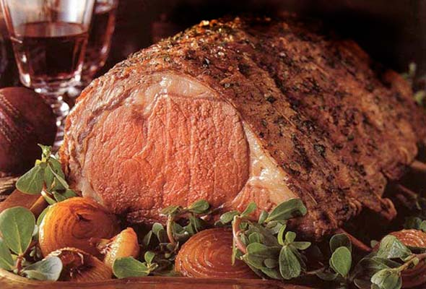
- Find a quote on Page 34 that shows Belle’s view of Scrooge linked to the theme of money.
- How did money affect Scrooge’s life for the worse in this section with Belle?

- How does the scene with Joe and Mrs Dilber reflect the coldness, and uncaring characters that are only interested in money? (P.62/63)

- What does Scrooge realise that his life pursuing wealth has amounted to? (P.65)

- How does Scrooge change and use his wealth for the good of others in Stave 5? Identify 3 ways: P.72, P.74, and P.75

