Quotation Booklet Year 11 Revision (Lord of the Flies Version)

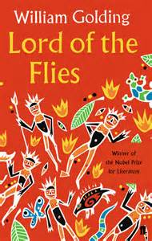

- Front page:
- Quotation learning top tips
- Romeo and Juliet, character and theme quotes (linked to language)
- Anthology Quotes (linked to language terminology)
- Anthology Context
- Lord of the Flies
- A Christmas Carol Key Quotes

Quotation work you can be doing to help with your revision
Repetition

Create Quote Posters

Memrise them

Use Quizlet

Create flashcards

Make/Do Quizzes

Start learning them early

Re-visit the texts - highlight

Use post it notes

Remember you can do this!
Revise, revisit and repeat

Romeo and Juliet by William Shakespeare
Character | Key Quotes linked to terminology and event
Prince of Verona  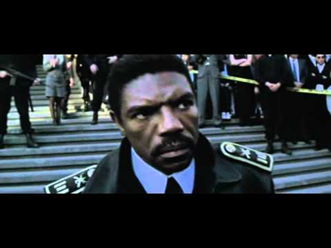 | - “If ever you disturb our streets again, your lives shall pay the forfeit of the peace” –Act 1:1 – The Prince issuing his ultimatum that execution will result for any participation in future fighting.  - “Let Romeo hence in haste, else when he is found, that hour is his last” Act 3:1 – The Prince banishing Romeo. If he returns he will be executed.  - “Capulet, Montague! See what a scourge is laid upon your hate…All are punished.” Act 5:3 – The Prince blaming the heads of both families for the ultimate deaths of their children.
Paris | - “Younger than she are happy mothers made” –Act 1:2 – Paris trying to persuade Capulet to allow him to take Juliet as his wife.  - “That ‘may be’ must be, love, on Thursday next.” – Act 4:1 –Modal into an Imperative. Paris speaking to Juliet in the church about his hopes of marrying her on Thursday.  - “O, I am slain! If thou be merciful, open the tomb, lay me with Juliet” –Act 5:3 Paris dying and hoping to be buried alongside Juliet. He isn’t.
Juliet  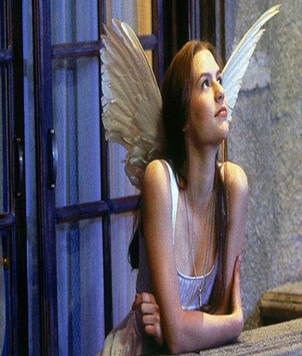 | - “You kiss by the book” Act 1:5 – metaphor – falling in love with Romeo  - “My only love sprung from my only hate” Act 1:5 – juxtaposition/Oxymoron – Realising Romeo’s family.  - “What’s in a name? That which we call any rose would smell as sweet.” Act 2:2 –metaphor –Juliet questioning whether Romeo’s family name should matter  - “My bounty is as boundless as the sea, my love as deep –the more I give to thee, the more I have, for both are infinite.” –Act 2:2- Hyperbole / simile – showing her love.  - “If that thy bent of love be honourable, thy purpose marriage, send me word tomorrow.” Act 2:2 – directive / Juliet checking Romeo’s intentions are genuine and geared towards marriage.  - “Methinks I see thee now, thou art so low, as are dead in the bottom of the tomb” Act 3:5 –Juliet has a vision of Romeo lying dead.  - “Proud I can never be of what I hate” Act 3:5 – Juliet saying to her father that she cannot be proud of his action that has led to her being paired with Paris.  - “Be not so long to speak, I long to die” Act 4:1 – Repetition/ Pun on long. Juliet asking Friar Laurence to get to a solution quickly!  - “Rather than marry Paris, bid me lurk where serpents are, chain me with roaring bears.” –hyperbole –showing Juliet is not keen on marrying Paris.  - “Pardon,I beseech you! Henceforward I am ever ruled by you.”Act 4:2 – Juliet promising to do as Capulet has instructed (after secretly securing the sleeping drug!)  - “What if when I am laid into the tomb,I wake before the time that Romeo come to redeem me?” Act 4:3– Use of questions – to consider the frightening thought that she might wake up alone in the tomb.  - “O happy dagger –let me die!”Act 5:3–Personification – Juliet before she kills herself.
Tybalt 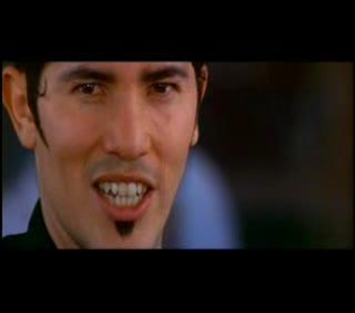 | - “What, drawn, and talk of peace! I hate the word, as I hate hell, all Montagues, and thee” –Act 1:1 –Repetition – Tybalt showing his primary character trait of loving fighting.  - “This, by his voice, should be a Montague.— Fetch me my rapier, boy.” Act 1:5 Tybalt recognises Romeo who has gatecrashed the party and wants to attack him.  - “Romeo, the love I bear thee can afford no better term than this: thou art a villain.”  - Act 3:1 – Metaphor – Tybalt damning Romeo’s actions at the party as no more than those of a common criminal.  - “Boy, this shall not excuse the injuries that thou hast done me. Therefore turn and draw.” Act 3:5 – Metaphor – Tybalt emphasising how he feels psychologically damaged by Romeo’s behaviour, and is therefore determined to fight.
Lord Capulet  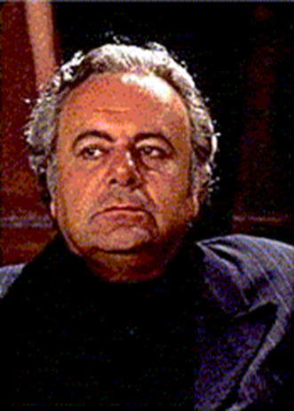 | - “What noise is this? Give me my long sword, ho!” Act 1:1 – Capulet keen to join in the fighting between the two families.  - “But Montague is bound as well as I, in penalty alike, and 'tis not hard, I think, For men so old as we to keep the peace.” – Act 1:2 – Capulet being obedient to the Prince’s instructions –vowing not to allow any more fighting between his family and the Montagues.  - “And, to say truth, Verona brags of him to be a virtuous and well-governed youth.” – Act 1:5 –Adjectives - At Capulet’s party, he admits that Romeo is an honourable, respectable young man.  - “O' Thursday let it be.—O' Thursday, tell her,she shall be married to this noble earl.” – Act 3:4 – Repetition / Adjective – Capulet now decided that his daughter should be married to respectable Paris.  - “It makes me mad. Day, night, hour, tide, time, work, play, alone, in company, still my care hath been to have her matched.” Act 3:5 – Listing – Capulet’s frustration that his hard work in trying to arrange a good marriage for Juliet has been not appreciated.  - “Speak not; reply not; do not answer me. An you be mine, I'll give you to my friend” – Act 3:5 – Directives / Objectification – Capulet insisting to Juliet that she is his property and she will be given to who he decides.  - “Life and these lips have long been separated. Death lies on her like an untimely frost upon the sweetest flower of all the field.” – Act 4:5 – Simile & Metaphor – Capulet is distraught at the sight of his supposedly dead daughter.  - “O brother Montague, give me thy hand.” –Act 5:3 – Capulet vowing to reconcile his differences with Lord Montague.
Lady Capulet  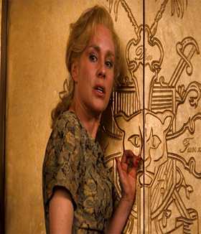 | - “Well think of marriage now; younger than you,” Act 1:3 – cajoling tone – questioning – LC is trying to persuade Juliet to marry Paris.  - “You are too hot.” – Act 3:5 short sentence – she is telling her husband not to be so angry with Juliet.  - “Do as thou wilt for I have done with thee” –Act 3:5 – Lady Capulet disassociating herself from her daughter’s disobedience, and telling her that she is on her own.  - “O woeful time!” Act 4:5 exclamation mark, adjective, despairing tone – LC has just learnt of her daughter’s death, she repeats the upset phrases of the nurse.
The Nurse  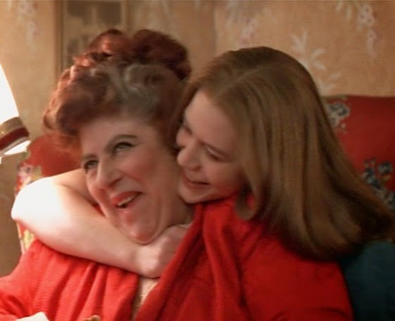 | - “What lamb? What Ladybird! God forbid, where’s this girl? What Juliet?” – Act 1: 3 – Rhetorical questions - nurse calling Juliet to speak to her mother.  - “Bigger women grow by men” Act 1:3 – The nurse’s love of innuendo comes out here, as she warns that women easily fall pregnant at the hands of men.  - “I am so vexed that every part about me quivers.” – Act 2:4 adjectives hyperbole – the nurse is angry about the way Romeo and his friends are speaking to her when she has met him to arrange the marriage.  - “I think you are happy in this second match, for it excels your first” – Act 3:5 Even the Nurse betrays Juliet by recommending she marries Paris.  - “She’s dead decease’d, she’s dead, she’s dead!” – Act 4:5 Repetition – The nurse alerts Lady Capulet to Juliet’s pretend death
Friar Laurence  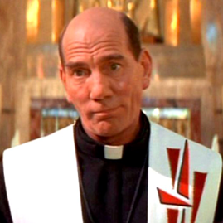 | - “For this alliance may so happy prove/To turn your households rancour to pure love.” A2:3 rhythmic/poetic/hopeful tone – FL agrees to marry R&J in the hope that it stops the fighting  - “Wisely and slow. They stumble that run fast.” Act 2:3 Friar Lawrence’s wise words against impulsivity.  - “Run to my study. – By and by! – God’s will,” – Act3:3 caesura, panicked tone, repetition – FL is begging Romeo to hide so he does not get caught before leaving for Mantua.  - “O Juliet, I already know thy grief,” Act 4:1 – compassionate tone, connotations, showing FL is aware of how Juliet feels about marrying Paris and that he is complicit in her possible bigamy if she does marry Paris.  - “A cold and drowsy humour;” – noun phrase, adjectives to show FL is plotting for Juliet to take a sleeping draught.  - “Get me an iron crow and bring it straight/Unto my cell.” Act 5:3 imperatives, FL realises the mistake he has made and tries to go straight to the tomb.  - “Come, I’ll dispose of thee among a sisterhood of Nuns.” Act 5:3 Friar Laurence plotting even at the end to try and help Juliet escape the marriage to Paris, even when the sleeping drug plan goes wrong.  - “here untimely lay, The noble Paris and true Romeo dead.” Act 5:3 anecdote – FL tells the assorted people of his plan and how this has unravelled most horrifically.
Benvolio | - “I do but keep the peace. Put up thy sword,” Appeasing tone. Short sentence – to show he doesn’t want to fight.  - “I’ll pay that doctrine, or else die in debt.” Hyperbole/exaggeration, alliteration to show he is loyal to Romeo.  - “Go then, for tis in vain/To seek him here” A2:2 – Imperative – leaving Romeo after the ball when he is in Juliet’s orchard.
Mercutio  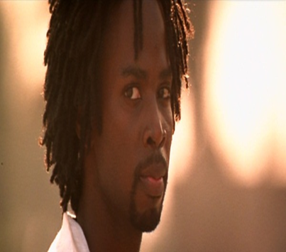 | - “Nay, gentle Romeo, we must have you dance” Act 1:4 Imperative ‘must’ persuading Romeo to go to the ball.  - “A bawd, a bawd, a bawd! So ho!” A2:4 – repetition insult suggesting he is a brothel keeper from the nurse which he repeats in an incredulous tone.  - “O calm, vile dishonourable submission” Act 3:1 – Adjectives – Mercutio not understanding why Romeo is cowardly and backing down from a fight with Tybalt.  - “A plague a’both your houses!” Act 3: 1 -Metaphor blaming both the Montagues and the Capulets and wishing them the most unpleasant death.
Romeo  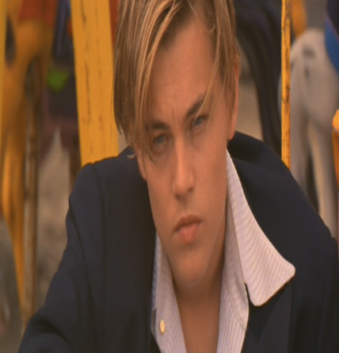 | - “In sadness, cousin, I do love a women” Act1:1 – juxtaposition Romeo swooning and pining for Rosaline.  - “I have lost myself. I am not here. This is not Romeo. He is some other where.” Act 1:1 Metaphor – Romeo’s unrequited love having a major effect on him.  - “By some vile forfeit of untimely death” act 1:5 foreshadowing –hinting at his own death before the ball scene.  - “o she doth teach the torches to burn bright!” act 1:5 Light Imagery and metaphor when speaking about Juliet at the ball .  - “Arise fair sun and kill the envious moon,” Act 2 Metaphor to show his rejection of Rosaline in favour of Juliet.  - “With love’s light wings did I o’erperch these walls,” Act 2:2” Celestial Imagery to show he is linked to God and the heavens.  - “But love thee better than thou canst devise” Act 3:1 exaggeration to persuade Tybalt not to fight.  - “O Juliet, thy beauty hath made me effeminate.” Act 3:1 Cursing his love of Juliet that has led to him behaving less like a man should, and Mercutio fighting and dying instead of him.  - “O I am Fortune’s fool” Act 3:1 –Metaphor/ Alliteration. Cursing fate after he has killed Tybalt  - “it was the lark, the herald of the morn, No nightingale” Foreshadowing, Symbolism, imagery Act 3:5 after the consummation of their marriage and before he is banished to Mantua.  - “…let me have/A dram of poison” Act 5:1 demanding tone to show he is in despair.  - “Death hath had no power yet upon thy beauty.” Act 5:3 Imagery to show that death hasn’t changed Juliet’s appearance yet – Shakespeare is playing with the audience here.  - “And shake the yoke of inauspicious stars from this world-wearied flesh” Act 5:3 –Metaphor and Alliteration to show Romeo’s desire to rid himself, through death, of fate’s control over him shortly before he dies.  - “Thus with a kiss I die” Act 5:3 statement first person – he dies
Lord Montague  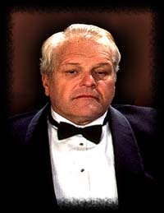 | - “With tears augmenting the fresh morning dew” Act 1: 1 – metaphor to show he is worried about Romeo.  - “Who set this new quarrel abroach?” Act 1:1 – Rhetorical question to find out how the fight started.  - “For I will raise her statue in pure gold,” Act 5:3 hyperbole, persuasion – Montague assures Capulet that he will erect a gold statue in her memory

The Eduqas Anthology
Poem | Suggested Key Quotes & Terminology Links
The Manhunt  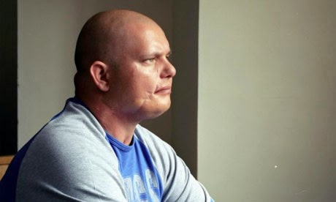  Eddie Beddoes after his injuries in the Bosnian Peacekeeping mission. | - “frozen river which ran through his face,”  Metaphor – links to tears and his physical appearance after the bullet scarred his face  - “handle and hold”  Alliteration – links to care that his wife Laura has to take with him as he is fragile  - “fractured rudder of his shoulder blade”  Metaphor – the damage to his shoulder which no longer works properly and the emotional damage of him being out of control or unable to steer his own emotions (rudder is used to steer a boat)  - “his grazed heart”  Noun Phrase – implies his heart is damaged, physically from the bullet sliding past it but emotionally from the fear he felt at nearly dying  - “foetus of metal beneath his chest”  Metaphor – the bullet is stuck inside him and may also link to his emotional state where he feels like a new person as a result of the injuries he has  - “sweating, unexploded mine/buried deep in his mind,”  Metaphor – pain he feels emotionally linked to the gunshot wound and the difficult progress of exploring these emotions
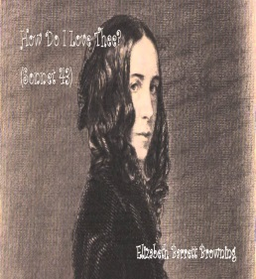  Sonnet 43  Barrett-Browning expressing her love in many ways. | - “How do I love thee?”  Rhetorical question – Opening the poem with an obvious indication of love  - “depth and breadth and height”  Triplets – showing how much love and how vast it is that it can’t be contained  - “I love thee”  Repetition x 6 – exploring again the idea that love is overwhelming and powerful  - Rhyme Scheme – ABBA ABBA CDCDCD and Sonnet form – love poem  Shows that even the way the poem is written is to explore the idea of how much love she has for him  - “Smiles, tears, of all my life! –“  Triplets – Linking to emotions of happiness
London  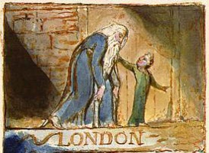  William Blake’s cynical interpretation of religious and societal expectations. | - “mark in every face I meet/ Marks of weakness, marks of woe.”  Triplets – what the poet notices in the faces of all the strangers he is around in town  - “In every”  Repetition – to show how much misery and despair he notices in others. It could be a social commentary on other people  - “Man…Infants cry…voice,”  Lexical set – linked to people and Blake’s observations of people and their links to religion  - “Soldiers sigh/Runs in blood down Palace walls.”  Sibilance – this suggests despair and an outcry against the deaths of soldiers which perhaps could have been avoided  - “blights with plagues”  Imagery – links to the bible and the way that wrath can be brought down on people and links to the disease which people of the time didn’t understand and thought could have been a sign of evil in the people with the plague
The Soldier  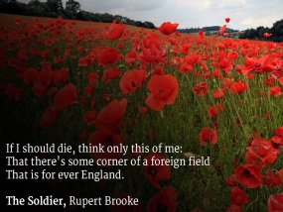  An idealistic representation of the horrors of war written before the true events became apparent. | - “of a foreign field”  Alliteration – the land which the soldiers will die in and be buried in when they fight but the insinuation is that they should be glad to die there  - “for ever England”  Metaphor – suggesting death doesn’t take the soldiers delight for their homeland away; when they die their death will leave a little piece of England in the foreign soil  - “England bore, shaped, made aware,/Gave, once, her flowers to love, her ways to roam,”  Listing – reinforcing the pride and patriotism every solider should have for their country and reinforcing the idea that death is brave and honourable  - “all evil shed away”  Metaphor – suggesting that the soldiers deaths will remove all evil and sin in the world  - “English heaven”  Repetition - of the symbolic idea of England as the motherland and linking to death
She Walks in Beauty  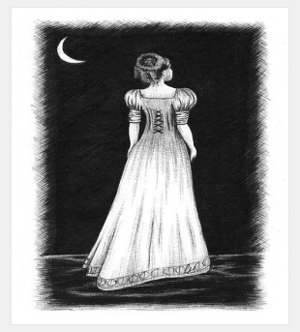  Byron captivated by the beauty of the female explores his feelings for her. | - “She walks in beauty,”  Second person – an exaggerated representation of the way that the persona in the poem feels about the women he is talking about  - “cloudless climes and starry skies;”  Imagery – showing how he compares her to heavenly imagery and how her beauty transcends the natural worlds beauty  - “Which waves in every raven tress,”  Adjectives – explores the colour and appearance of her beautiful dark coloured hair  - “serenely sweet express,”  Sibilance – the persona is exploring again how much he feels for the beautiful women he is talking about  - “So soft, so calm, yet eloquent,”  Triplets – exploring attributes that he feels she has
Living Space  An outlook on how difficult it is to live in shanty town conditions with not enough space, clean water or basic humanitarian needs. | - “That /is the problem.”  Enjambment – expressing that the physical appearance of the area is the main problem when the problem is societal as well as space  - “Beams/balance crookedly”  Adverb – suggesting that everything is wrong and the physical space is also expressing this too.  - “someone has squeezed/ a living space”  Sibilance – implies that it is alien and out of place and that it is not a natural or normal way to have to live.  - “slanted universe,”  Metaphor – again a reference to the way that people have to live in terrible conditions but a metaphor for the difference between their way of living and the more wealthy.  - “bright, thin walls of faith.”  Metaphor – the idea that religion can give hope for a better life linked to the way the people have to live in shacks which are not fit to be living spaces but poverty gives them no choice, while religion can give them hope.
As Imperceptibly as grief  Dickenson suggests she would rather be elsewhere and is consumed by her grief. | - “As imperceptibly as Grief”  Metaphor – you can’t touch or see or truly feel grief it is an unknown until you have experienced it  - “To seem like Perfidy —“  Tentative – infers that it looks like deceitfulness or an untrustworthy idea  - “The Dusk drew earlier in —“  Imagery – creates a sense of pathetic fallacy as if the evening is coming in quickly and making her feel more sad  - “Our Summer made her light escape”  Metaphor – to suggest that her happiness is what is escaping (Dickenson’s)  - “Into the Beautiful.”  Adjective – could be making her think that she wants to escape to somewhere where she will be happy
Cozy Apologia  Dove depicts a contented relationship against the background of a hurricane. | - “I could pick anything and think of you—“  End-stopping – autobiographical with reference to her husband  - “with furrowed brow/ And chain mail glinting, to set me free:”  Rule of three – dreamlike and fantastical tone  - “Oddly male: Big Bad Floyd,”  Caesura – reinforcing the maleness and strength of the hurricane which is coming up the coast. It feels unpredictable.  - “teenage crushes on worthless boys”  Adjectives – to describe memories of previous relationships  - “You’re bunkered in your/ Aerie,”  Caesura – suggests comfort and being safe  - “I fill this stolen time with you.”  First person - shows contentment and happiness as they are forced to stop and be in the same place but are happy about this.
Valentine  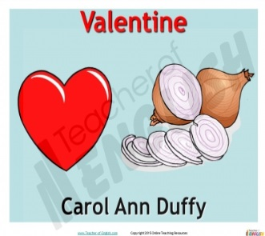  Duffy gives a realistic interpretation of love using an extended metaphor. | - “I give you an onion.”  Statement - showing that love can be reduced to mundane everyday items not just the stereotypical flowers and chocolates. Love is real and causes more than just happy emotions.  - “It will blind you with tears/ like a lover.”  Simile – to show that the scent of the onion can make you cry in the same way that a relationship has that power.  - “Its fierce kiss will stay on your lips, / possessive and faithful”  Metaphor – literally the onions flavour or metaphorically the relationships kiss suggesting it is always there clinging to you and a part of you when you are in it.  - “Lethal.”  Single sentence line – reinforcing the pain that can be caused unknowingly in a relationship  “Its scent will cling to your fingers,/cling to your knife.”  Repetition – like the scent of the onion once you’ve had love it sticks with you.
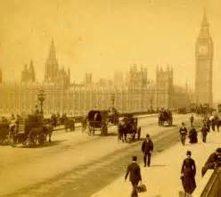  A Wife In London  Hardy reflects on the irony of receiving a telegram reporting a death one day and the next receiving a love letter from the Boer War. | - “tawny vapour”  Metaphor – referencing the fog which is enveloping the city and perhaps using pathetic fallacy to enforce how the wife feels emotionally when she hears the news of her husband’s death.  - “uprolled”  Verb – repetition of the image of the fog.  - “webby fold on fold”  Repetition – again the fog being referenced and setting a sombre upset tone.  (all these are a lexical set relating to fog)  - “cracks smartly,”  Onomatopoeia – the sound emphasised of the knock on the door from the messenger.  - “Flashed news”  Noun phrase – she receives news that her husband has died  (Lexical set relating to sounds)  - “firelight flickers”  Alliteration – reinforcing melancholy and sadness as the woman sits alone upset and aware of her husband’s death.  - “whom the worm now knows:”  Metaphor – morbid imagery of the husband being buried away from home.  - “highest feather - ”  Metaphor – joyful tone of the letter sent from the husband telling her of his love and his imminent return home to London.
Death of a Naturalist  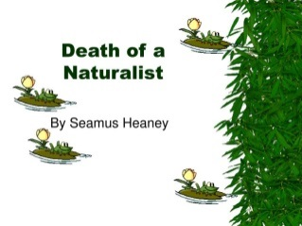  Heaney describes the joy of discovering nature in childhood juxtaposed with fear of nature in later years. | - “gargled delicately,”  Verb and adverb – exploring how nature was a thing of wonder and discovery.  - “frogspawn that grew like clotted water”  Simile – excitement of watching the tadpoles grow and expand and come to life  - “wait and watch until/The fattening dots”  Alliteration – anticipation of the fattening of the tadpoles  - “were rank”  Adjective – negativity towards the smell and appearance of nature.  - “loose necks pulsed like sails”  Simile – repulsion at the appearance of the toads and frogs which have now grown up similar to the now grown up man, who once revelled in the joy of discovering nature but is threatened by the sight as a man.  - “Poised like mud grenades,”  Simile – negative exploration of the way the frogs move and the negative colour of them implying he doesn’t like the frogs and is threatened by them.
Hawk Roosting  The Hawks viewpoint is given in the poem to show how in charge and dominant in nature he is. | - “rehearse perfect kills and eat.”  Verb and adjective – chosen to perhaps imply that this is what the Hawk is made for. He deserves to kill and eat whatever he chooses.  - “earth’s face upward for my inspection”  Metaphor – implying that the Hawk believes that the earth is there for him to observe and watch and that he is stronger than nature  - “Creation”  Biblical symbolism – linking to the fact that the hawk thinks he is a god-like authority  - “My manners are tearing off heads”  Violent imagery - showing how the hawk has no thought or feelings other than to kill  - “has permitted no change”  Imperative – nothing has changed because the hawk arrogantly believes he has not allowed it
To Autumn  Keats explores how Autumn is a beautiful season but metaphorically could be suggesting the seasons are linked to life and death. | - “mists of mellow fruitfulness!”  Alliteration – joyful exploration of the start of the autumn season and the end of summer which has allowed the fruits to be ready to  - “swell the gourd”  Imagery – the sun has given an abundance of harvest for people to gather and collect to keep them going over the winter months.  - “o’erbrimm’d their clammy cells.”  Adjective – again life has been provided and the harvest is plentiful and enjoyable  - “mid thy store?”  Rhetorical question – suggesting that life has quietened down in the end of autumn and perhaps towards the middle of life too in this second stanza.  - “Winnowing wind;”  Alliteration – the wind is gentle and quiet reflecting the gentleness of the season.  - “half reaped furrow sound asleep,”  Adjectives – suggesting there is time to sleep and rest now that the harvest has nearly been taken in. It gives a very calm tone to the poem.
Afternoons  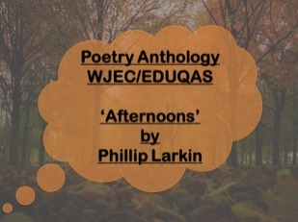  A poem reflecting on the subject of marriage. | - “Summer is fading:”  End-stopping – suggesting that a time of freedom is coming to an end.  - “At swing and sandpit/ Setting free”  Sibilance – suggesting the mothers or married women are isolated and lonely and that symbolically they have lost the freedom that they once had.  - “Lettered/Our Wedding, lying”  Italics – pushed aside and forgotten, what once was a joyful and exciting phase has been discarded and overtaken by mundanity.  - “That are still courting-places”  Enjambment – wistfulness as a result of marrying and having children so young perhaps.  - “Their beauty has thickened.”  Metaphor – suggesting that the young mothers have lost the freedom that they once have and that they are now more cynical as a result.
Dulce et Decorum Est  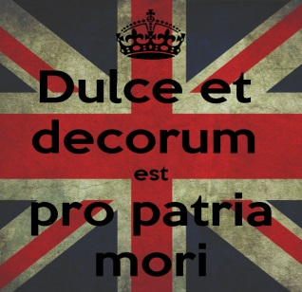  Owen responds to the horror and lies told about war with an honest and brutal depiction of life in the trenches. | - “Bent double, like old beggars under sacks,/Knock-kneed, coughing like hags,”  Similes – showing how young men were literally brought to their knees and made ill by the horrors of war and what they had to do. Their health both physically and mentally was affected.  - “Of gas shells dropping softly behind.”  Sibilance – they are so used to the loud noises of war that they almost can’t hear the gas being dropped.  - “Gas! Gas! Quick, boys! – An ecstasy of fumbling,”  Caesura – reinforces the panic of trying to get their gas masks on in time so that they don’t die from the gas poisoning. Juxtaposing words reinforce how difficult and time constrained this is.  - “He plunges at me, guttering, choking, drowning.”  Triplets – the death of a fellow soldier who didn’t manage to put his gas mask on in time.  - “like a devil’s sick of sin;”  Symbolism – even the devil has had enough of the pain and suffering in the name of a greater cause.  - “My friend, you would not tell with such high zest”  Directive – telling the reader if they experienced the terror and pain and sights of war they would not be so willing to lie about the conditions and make it sound ok
Ozymandias  Shelley reflects on the power of a ruler who had a statue erected for him that has now been destroyed. | - “I met a traveller from an antique land”  First person – old and suggestion of the traveller as a wise man who has a story to tell.  - “Two vast and trunkless legs of stone”  Adjectives – the statue is ruined and lies forgotten in the desert  - “Half sunk, a shattered visage lies, whose frown, / And wrinkled lip, and sneer of cold command,”  Listing – shows the horrible character of the ruler that the statue depicts.  - “Ozymandias, king of kings:/ …ye Mighty, and despair!’”  Proper noun – showing the power and arrogance of the ruler when he was alive  - “The lone and level sands stretch far away.”  Sibilance – loneliness and forgotten nature of the statue in the middle of the desert reflects that no matter how powerful you were in life you won’t be remembered favourably afterwards if you are morally corrupt.
Mametz Wood  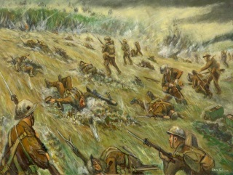  Sheers reflects back on the waste of life to the Welsh regiment who were sent to their deaths at Mametz Wood and never given credit for their actions. | - “afterwards the farmers found them –“  End-stopping – farmers were ploughing up pieces of the soldiers for years and years afterwards.  - “wasted young,”  Adjective – showing what a terrible thing it was for the Welsh soldiers and also that it could have been avoidable if the sergeants hadn’t been so blasé about sending them into the woods.  - “the blown/ and broken bird’s egg of a skull,”  Metaphor – harsh sounds reinforce the suddenness of the deaths of the men and the violence with which it happened. They had no chance to help themselves or protect themselves.  - “twenty men buried in one long grave,”  Imagery – Shows how quickly and unaware they were of the danger.  - “slipped from their absent tongues.”  End-stopping – reinforcing that these men had no voice at the time they just had to follow orders and also shows how they lost their physical tongues when they died too.
Excerpt from the Prelude  Wordsworth explores his awe of nature and younger self in this autobiographical ‘snippet’ from his long poem. | - “twilight blaz’d,”  Light imagery – showing that it was early evening and suggesting that it was a beautiful time of day.  - “It was a time of rapture: clear and loud”  Emotive language – showing how happy he was at this point.  - “hiss’d along the polish’d ice,”  Verb – showing how fast he and his friends were skating and how free they were as a result.  - “The Pack loud bellowing,”  Metaphor – could be the hunting of animals in the wood or the sound of the boys playing on the ice sounding like a pack of animals.  - “the precipices rang aloud,”  Personification – of the hills suggesting a sense of danger or awe of the vastness of the area  - “The orange sky of evening died away.”  Imagery – linked to the beauty of the sky as evening faded.

Lord of The Flies
Character | Key Quotations
Ralph  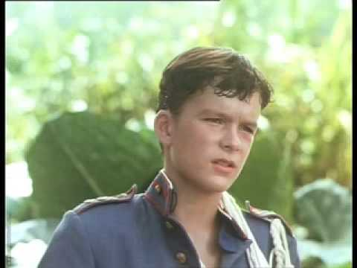 | - "there was a mildness about his mouth and eyes that proclaimed no devil."  - Imagery – physical description – links to Ralph’s innocence.  - “There was a stillness about Ralph as he sat that marked him out: there was his size and attractive appearance."  - Imagery – clear leader by appearance. Stereotypical hero.  - "You aren't playing the game".  - "I'm chief. I'll go. Don't argue."  - Short sentences – commanding yet heroic.  - “But I tell you that smoke is more important than the pig, however often you kill one.”  - Symbolic imagery: brains better than brawn/ civilisation better than savagery.  - “Things are breaking up. I don't understand why. We began well; we were happy. And then -- ...Then people started getting frightened.”  - Semi-colon and dashes emphasise how the boys are breaking up/fractured.  - “The world, that understandable and lawful word, was slipping away. Once there was this and that; and now -- and the ship had gone.”  - Embedded clause makes that world seem even more distant. Dash emphasises seriousness of missing the ship.  - “Ralph too was fighting to get near, to get a handful of that brown, vulnerable flesh. The desire to squeeze and hurt was over-mastering.”  - Violence is almost personified here/given power over the boys. Violent verbs.  - “Ralph wept for the end of innocence, the darkness of man's heart, and the fall through the air of a true, wise friend called Piggy.”  - Triples – emphasises what Ralph has lost on the island.
Piggy  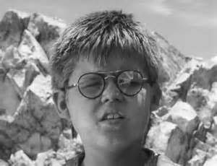 | - "Piggy, for all his ludicrous body, had brains."  - Description – Piggy is ridiculed for his appearance but represents intelligence/ civilisation on the island.  - “Piggy was an outsider, not only by accent, which did not matter, but by fat, and ass-mar, and specs, and a certain disinclination to manual labour."  - Listing – emphasises differences between Piggy and the other boys and shows his ‘otherness’  - "Acting like a crowd of kids".  - Short sentence – Expresses Piggy’s intelligence and maturity, but also represents him as outsider and civilised opposed to savage.  - "It was an accident... and that's that".  Noun – “accident” – removing blame/ trying to justify killing of Simon. Refers to ‘it’ – can’t mention the word.  - “I just take the conch to say this. I can't see no more and I got to get my glasses back".  Symbolic imagery – Glasses symbolise order/civilisation – boys taking Piggy’s glasses is like them trying to take civilisation away.  - "I got the conch!"  Short sentence – conch symbolises order – should be enough to allow Piggy to speak but others reject this symbol.  - "the true, wise friend called Piggy".  Adjectives – summarises Piggy throughout novel.  - “with the martyred expression of a parent who has to keep up with the senseless ebullience of the children” – metaphorical parent – symbolises intelligence and protection. “martyred” suggests holy while “senseless” emphasises senseless killings.
Jack | - His face was crumpled and freckled, and ugly without silliness".  Imagery – typical antagonist from first description.  - "See? They do what I want."  Rhetorical question and short statement – emphasises Jack’s power and control over choir.  - "the enormity of the knife descending and cutting into living flesh; because of the unbearable blood".  Imagery – Jack is unable to kill pig at first – violent imagery explains why this task was difficult.  - "All you can talk about is pig, pig, pig!" Ralph says angrily.  Repetition – emphasises that this is all that Jack care about. Pig/killing/savagery.  - "they had outwitted a living thing, imposed their will on it, taken away its life".  Triples – after killing the pig. Jack celebrates killing and taking control/power. Celebrating.  - "His voice was vicious".  Short sentence – cutting and direct. Adjective implies evil/ brutality.  - "Bollocks to the rules! We're strong - we hunt!"  Obscene language – reflects lack of order/parents/civilisation. Emphasises lack of respect for these things. Collective pronouns suggest unity.  - "We don't need the conch any more".  Collective pronoun – group but Jack is still leader. Abandons rules/civilisation.  - “I agree with Ralph. We've got to have rules and obey them. After all, we're not savages. We're English.”  Ironic that Jack says this at the start but he is possibly most savage and introduces concept of savagery with hunting/masks.  - “He tried to convey the compulsion to track down and kill that was swallowing him up.”  Metaphorically being consumed by the desire to kill – makes the desire to harm seem more powerful than anything.  - “If you're hunting sometimes... you can feel as if you're not hunting, but -- being hunted.”  Paranoia setting in/ fight for survival.  - “...the mask was a thing on its own, behind which Jack hid, liberated from shame and self-consciousness.”  Metaphor for savagery. Mask gives Jack freedom/disguise so he can act outside of social norms.  - “I'm not going to play any longer. Not with you.”  Childish language – reinforces the fact that they are just children after all. Idea of game getting out of hand.
Roger | - "slight” and "furtive".  Animalistic imagery – described like a cat/ predator. Links to his desire to hunt and kill.  - "The shock of black hair, down his nape and low on his forehead, seemed to suit his gloomy face and make what had seemed at first unsociable remoteness in to something foreboding."  Dark imagery – suits his dark characteristics. Could be symbolic of death (kills Piggy)  - "carried death in his hands".  Metaphor – emphasises the power and destruction he wields on the island.  - “...there was a space around Henry, perhaps six yards in diameter, into which he dare not throw. Here, invisible yet strong, was the taboo of the old life.”  At start Roger still controlled by rules/order and doesn’t harm boys. Eventually this is stripped away.
Simon  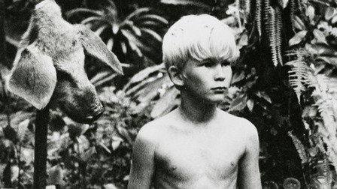 | - "a skinny, vivid little boy”  Imagery – adjective ‘vivid’ could link to his dreams/visions but also means bright/shining which could like to his knowledge/symbol of hope.  - “Like candles. Candle bushes. Candle bud.”  Repetition – emphasise his brightness/symbol of hope but also that his life is extinguished  - "He's queer. He's funny." Piggy says "He's cracked".  Triples – emphasises Simon’s difference – even more ironic coming from Piggy who is also different.  - He has "a secret place in a clearing full of flowers and butterflies",  Natural imagery – links to calm/sensitive characteristics.  - "He walked with an accustomed tread through the fruit trees."  Natural imagery – at one with nature. Knows the paths/ routes.  - "maybe there is a beast... What I mean is... maybe it's only us".  Simon is the only character to work out that their only fear/ only threat is each other. Repetition of ‘maybe’ and use of ellipses – links to uncertainty and lack of confidence.  - “The waves turned the corpse gently in the water. ... Softly, surrounded by a fringe of bright inquisitive creatures, itself a silver shape beneath the steadfast constellations, Simon's dead body moved out towards the open sea".  Gentle adverbs to emphasise his gentleness. Light imagery represents his goodness and ‘Christ-like’ characteristics.  - “The beast was harmless and horrible; and the news must reach the others as soon as possible.”  Refers the pig’s head talking to Simon when he hallucinated. Alliteration. Simon knew the truth – messenger – links to Jesus.
A Christmas Carol
Character | Link to quote, terminology and meaning
Scrooge  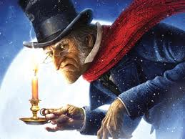 | - “Hard and sharp as flint”  Simile – to show his miserly nature  - “Solitary as an oyster”  Simile – to show how lonely and isolated he was  - “He carried his own low temperature around with him”  Metaphor – for his poor attitude and way he made others feel when he saw them.  - “Nobody stopped him in the street to say. ‘My dear Scrooge, how are you?’ ”  Metaphor – for his dislikeable and unfriendly character.  - “Bah! Humbug”  Exclamations – this is only repeated a couple of times but has become iconic as a representation of Scrooge’s dislike of spending and Christmas.  - “Every idiot who goes around with Merry Xmas on his lips... should be buried with a stake of holly through his heart”  Tone – shows how dislikeable Scrooge is and how much he hates Christmas as he has to stop making money for a day.  - “Are there no prisons? Are there no workhouses?”  Rhetorical Questions – suggesting the poor are at fault for having no money and that they have a place in society (even though we know prison and workhouses were terrible places)  - “If they would rather die, they had better do it and decrease the surplus population”  Metaphor – to show that poor people should die and free up space for other people and for making more money.  - “It’s not my business”  Tone – showing he isn’t interested in what happens to others.  THE CHANGE!  - “I will honour Christmas in my heart. I will live in the Past, the Present, and the Future. I will not shut out the lessons that they teach.”  Repetition – showing how he has had an epiphany and is no longer the miserly begrudging character he once was.  - “I am light as a feather, I am as happy as an angel, I am as merry as a schoolboy, I am giddy as a drunken man. A merry Christmas to everybody. Hallo! Whoop! Hallo!”  Repetition of the personal pronoun – shows his light hearted and carefree attitude and his lack of care about money and material goods.  - “I don’t know anything. I’m quite a baby.”  First person – Shows he is re-born as a decent person.  - “I’ll send it to Bob Cratchit!”  Statement – showing he is capable of charity by sending a decent goose to the Cratchit family.  - “Not a farthing less. A great many back payments are included in it.”  Short sentences – showing that Scrooge recognises that his wagers have been disproportionate and unfair to Bob.  - “I have come to dinner. Will you let me in Fred?”  Question – showing his uncertainty about his position with his nephew Fred due to the way he has always behaved in the past.  - “Therefore I am about to raise your salary!”  Emotive tone – showing he is being fair to Bob  - “Scrooge was better than his word. He did it all and became as good a friend, as good a master, and as good  a man, as the good old city knew.”  Repetition – showing he is good to his word and that he became a different person.
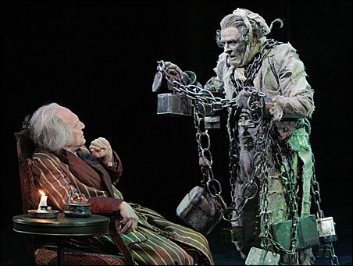  Marley | - “On the very day of the funeral, (Scrooge) solemnised it with an undoubted bargain”  Negative tone – showing how Scrooge had already forgotten his friend and business partner.  - “I wear the chain I forged in life...The chain was made up of cash boxes..ledgers..heavy purses”  Metaphor – to show that the way he had behaved in life had a direct impact on him in the afterlife – he is now in purgatory and damned to walk the earth with heavy chains representing everything he valued in life  - “You may be an undigested bit of beef”  Metaphor – to show that Scrooge doesn’t really believe the spectral vision he is having at the moment.  - “My spirit never roved beyond the narrow limits of our money changing hole”  Metaphor – to show he was doomed in life due to his obsession with money and that this carries on in death too.  - “Mankind was my business!”  Symbolism – shows he understands the error of his ways and that money isn’t the be all and end all.
Bob Cratchit and Cratchit Family  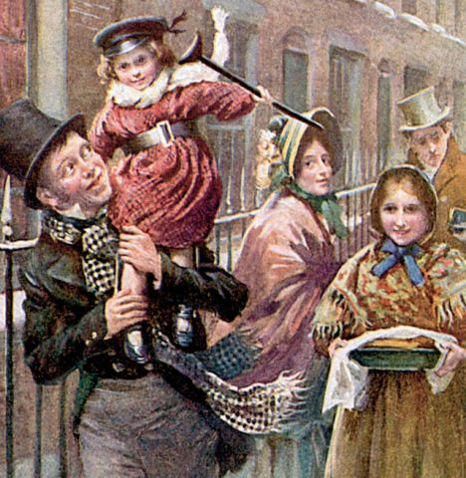 | - “The clerk’s fire was so very much smaller that it looked like only one coal”  Hyperbole – shows the terrible cold and conditions that Scrooge makes Bob work in.  - “There’s another fellow, my clerk with fifteen shillings a week, and a wife and family, talking about a merry Christmas. I’ll retire to Bedlam”  Statements – shows how little he pays Bob and how dismissive Scrooge is of his cheerful nature.  - “Tiny Tim hoped the people saw him in the church, because he was a cripple, and remember upon Christmas day, who made lame beggars walk, and blind men see.”  Religious connotations – Tiny Tim reinforces Christian values of charity, kindness and being thankful for what you have.  - “Mrs Cratchit made the gravy hissing hot, Master Peter mashed the potatoes with incredible vigour, Miss Belinda sweetened up the apple sauce...”  Listing – showing the family work together and that love is more important than money and materialistic goods.  - “There never was such a goose cooked.”  Hyperbole – showing they exaggerate the excitement of a goose which is too small for them as a family but they are grateful anyway.  - “Eked out by apple-sauce and mashed potatoes”  Adjective – shows that there isn’t enough food to go around  - “God bless us every one”  Religious Imagery – Tiny Tim again reinforces charity and peace and happiness to all mankind at Christmas time.  - “Mr Scrooge. I’d give him a piece of my mind. An  odious, stingy, hard, unfeeling man” (Mrs Cratchit)  Listing – the negative tone shows how unhappy she is with the way that Bob is treated by his employer.
Belle | - “Another idol has displaced me.. a golden one”  Metaphor – to show that money has become more important to Scrooge than his fiancé Belle.  - “I have seen your nobler aspirations fall off, until the master passion, Gain engrosses you”  Triplets – to show her disappointment in the change in him.  - “May you be happy in the life you have chosen”  Statement – She wishes him luck and shows that she is leaving him due to his money grabbing ways.  - “No more! Show me no more!”  Repetition – Scrooge can no longer watch his previous self and the loss of the love he had for Belle.  - “Now a comely matron sitting opposite her daughter”  Adjectives – shows how she is happily married and satisfied with her life but also highlights the happiness Scrooge has missed out on.
Fred – nephew of Scrooge  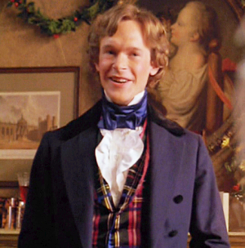 | - “What reason have you to be morose? You’re rich enough.”  Questioning – shows the difference in attitude between Fred and Scrooge and encourages Scrooge to be a happier more pleasant man.  - “I have always thought of Christmas as a good time, a kind, forgiving, charitable, pleasant time”  Listing – shows Fred’s love of Christmas and his clear difference in attitude to his uncle.  - “Don’t be angry Uncle. Merry Christmas!”  Short Sentences – showing that he is happy, like Christmas and charitable.  - “If you should happen, by any unlikely chance, to know a man more blest in a laugh than Scrooge’s nephew, all I can say is I should like to know him too.”  Narrative voice – reinforces how pleasant and nice Fred is.  - “Scrooge’s offences carry their own punishment. Who suffers? Himself!”  Dialogue – showing he understands that Scrooge is his own worst enemy.
Minor Characters:  Fan  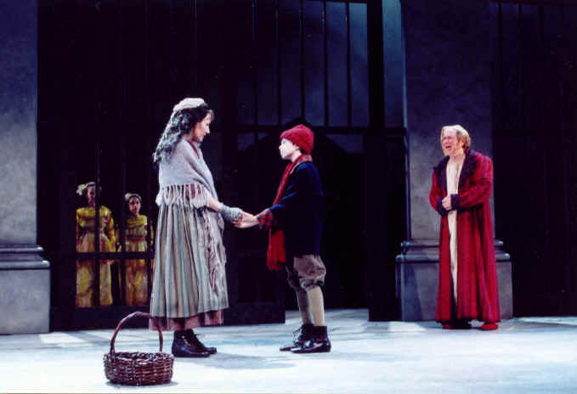  Fezziwig  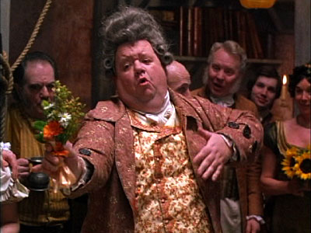  Mrs Dilber, the laundress and Joe  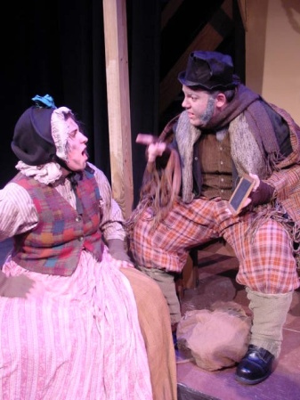 | - “I have come to bring you home dear brother.. home, home, home!”  Repetition – showing that he was loved and loveable once but also reinforces the fact that his father didn’t want him around  - “You are quite a woman, little Fan”  Exclamation – showing he loved and admired his sister when they were young.  - “Bless his heart; it’s Fezziwig alive again!”  Happy Tone – showing that he has fond memories of his old employer.  - “Yo ho there! Ebenezer! Dick! No more work tonight!”  Jolly Tone – showing how charitable Fezziwig is by stopping them from working to have a Christmas Party.  - “He has the power to render us happy or unhappy; to make our service light or burdensome. The happiness he gives, is..as if it cost a fortune”  Epiphany – Scrooge realises that happiness doesn’t have to cost a fortune and that Fezziwig was a good employer.  - “Who’s the worse for the loss of a few things like these? Not a dead man I suppose.”  Dialogue – showing they don’t care about Scrooge and are happy to steal his possessions from him after his death.  - “He’d have had somebody to look after him when he was struck by Death, instead of lying gasping out his last there, alone by himself”  Dialogue – shows he died alone and unhappy.
The Ghosts  Ghost of Xmas Past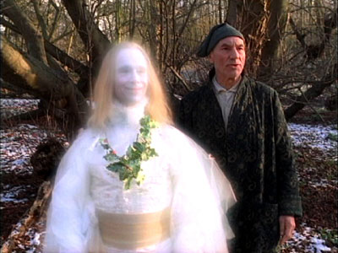 | - “Would you (Scrooge) so soon put out..the light I give?”  Metaphor – to show that the first ghost is there to illuminate his past and show him where things have gone wrong.  - “Scrooge was conscious of a thousand odours floating in the air, each one connected with a thousand thoughts and hopes and joys long long forgotten.”  Triplets – to show Scrooge once had dreams and thoughts and hopes like everyone else.  - “Strange to have forgotten it for so many years”  Statement – shows that Scrooge is not very reflective and doesn’t look back or try to adapt the way he is.  - “A solitary child, neglected by his friends, is left there still – Scrooge sobbed.”  Sibilance – shows how lonely Scrooge was as a child and the memory makes Scrooge unhappy as an adult.  - “To see Scrooge’s extraordinary voice between laughing and crying..and his excited face..would have been a surprise to his business friends in the city”  Emotive Language – shows that Scrooge is capable of emotion and that he isn’t heartless.  - “I should like to have given him (the boy carol singer)something: that’s all.”  First person – Scrooge thinks of someone kindly unlike his normal behaviour.  - “One child: true! your nephew!”  Exclamatory tone – the remembrance that he loved Fan (his sister) and he has neglected his duty as an uncle towards her son.  - (With Fezziwig) “Scrooge’s heart and soul were in the scene..he remembered everything, enjoyed everything.”  Repetition – shows Scrooge is capable of happiness or has been in the past.  - “A small matter to make these folks so full of gratitude”  Epiphany – shows that it is easy to make employees happy.  - “I should like to be able to say a word or two to my clerk just now. That’s all.”  Tone – shows that he is reflecting on his behaviour towards Bob.
Ghost of Xmas Present  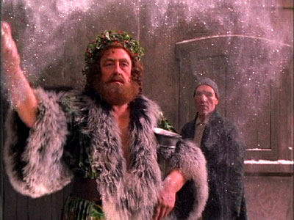 | - “A jolly giant who bore a glowing torch with a cheery voice and a joyful air”  Description – showing his benevolent nature  - “To a poor one most. Because it needs it most”  Repetition – to show the poor are in most need.  - “I see a vacant seat. The child will die”  Short sentences – emphasise the hole that would be left in the Cratchit family if Tiny Tim died.  - “Will you decide what men shall live, what men shall die? It may be in the sight of heaven, you are more worthless and less fit to live than millions like this poor man’s child”  Symbolism – The ghost is teaching Scrooge a lesson about humanity.  - “Scrooge was the ogre of the family and the mention of his name cast a dark shadow”  Hyperbole – showing how the rest of the family felt about Scrooge.  - “The numbers of people on the way to friendly gatherings”  Description – showing that even the poorest had love and friendship.  - “Even here.. two men wished each other Merry Christmas in their can of grog.”  Symbolism – even in the lowliest of places people showed kindness and Christmas spirit.  - “Yes/No game.. a disagreeable, savage animal. It’s Uncle Scro-o-o-o-ge!”  Adjectives – to show the family poking fun at Scrooge behind his back.  - “They are Man’s. This boy is Ignorance. This girl is Want. Beware for I see that written which is Doom.”  Symbolism – giving us a lesson about the nature of humans and the dark path that this will lead humanity down.
Ghost of Xmas Future  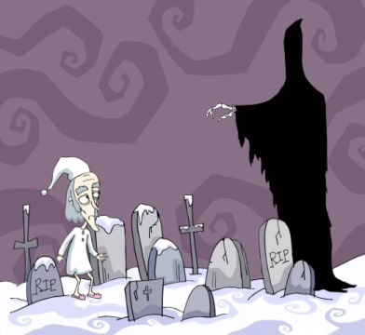 | - “It was shrouded in a deep black garment which concealed its head, its face, its form and left nothing visible except one outstretched hand”  Symbolism – describing the ghost like he is the grim reaper  - “Ghost of the Future. I fear you more than any spectre I have seen. But as I know your purpose is to do me good, I am prepared to bear you company with a thankful heart.”  Epiphany – Scrooge recognises that he needs to listen to the ghost and this is the first time that has happened.  - “I don’t mind going (to the funeral) if a lunch is provided.”  Emotive Language – showing that the businessmen don’t care that Scrooge is dead they are only after a free lunch.  - “Old Scratch has got his own at last hey?”  Rhetorical Question – showing his nickname isn’t particularly well respected.  - “So I am told.. Cold isn’t it?”  Rhetorical question – others speaking about Scrooge with no feeling.  - “He frightened everyone away from him when he was alive, to profit us when he was dead, ha, ha!”  Mocking tone – showing that nobody cares about his death.  - “If there is any person in the town who feels emotion caused by this man’s death, show that person to me, Spirit, I beseech you!”  Desperate tone – Scrooge is begging the ghost to show someone will miss him.  - “It would be bad fortune to find so merciless a creditor. We may sleep tonight with light hearts, Caroline!”  Relieved tone – creditors of Scrooge are relieved they are not in debt to him any more as no one could be worse.  - “I am sure none we shall none of us forget Tiny Tim”  Repetition – grief at the death of Tiny Tim.  - “A churchyard, overrun by weeds, the growth of vegetation’s death not life –a worthy place!”  Triplets – showing nobody ever visited Scrooge’s grave or cared.  - “Scrooge crept towards it, trembling, and following the finger, read upon the stone of the neglected grave his own name, Ebenezer Scrooge.”  Complex sentence – reveals his emotion at seeing how little anyone cares for him or remembers him.

