Mini Context for The Anthology @Eduqas
The Manhunt  Peacekeeper  Relationship trouble  Emotional pain  Physical pain  PTSD – Post traumatic stress disorder | Sonnet 43  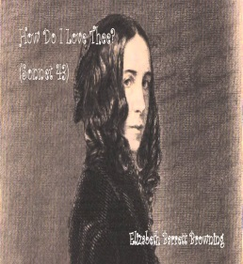  Love for husband  Escapism  Parents difficult  Emotional | London  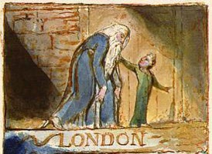  Victorian London  Religious cynic  Romantic Poet  Social concept addressed | The Soldier  Propaganda  Never fought  Died out of war  Persuasive  unrealistic  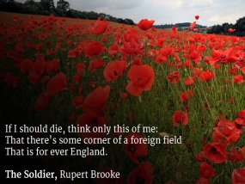 | She walks in Beauty  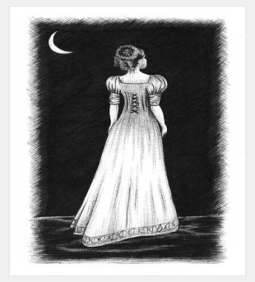  About his cousin  At a funeral  Depicts love of physical beauty  Well known lothario | Living Space  India  Slums  Social concept  Poverty
As imperceptibly as Grief  Reclusive poet  Wide reader  Interest in civil war  Father was an American congressman | Cozy Apologia  Autobiographical poem  About Hurricane Floyd  1999  Love and comfort | Valentine  Realism of love  Depiction of relationships  Poet Laureate  Contemporary poet | A Wife in London  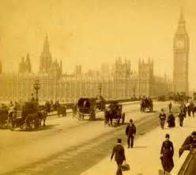  Boer War  Telegram before love letter  Highlights female pain of war  isolation | Death of a Naturalist  Irish poet  Grew up in countryside  Sent to school  Fear of nature as an adult | Hawk Roosting  Nazi symbol  Power  Concept of nature owning the world  Cynicism about religion
To Autumn  Romantic poet  Idealistic  TB – Impending death  Reflection on life/death | Afternoons  Larkin’s cynical views on relationships  Family life non-existent | Dulce et Decorum Est  WW1  Battle of the Somme  Died in battle just before the end of war  Sickened by violence | Ozymandias  Arrogance of rulers  Egyptian ruler  Shelley a rebel | Mametz Wood  Welsh regiment  Told to walk into the woods  Forgotten soldiers  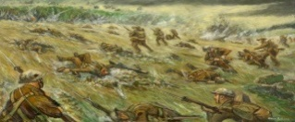  Quick deaths | Excerpt from the Prelude  Lake District  Autobiographical account  Depicts innocence in childhood  Fear of nature

