Micro Quotations for The Anthology @Eduqas
The Manhunt  Passionate  Rungs  Damaged  Grazed  Mine | Sonnet 43  Love  Soul  Freely  Saints  Death  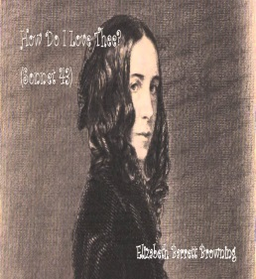 | London  Wander  Weakness  Woe  Man  Plague  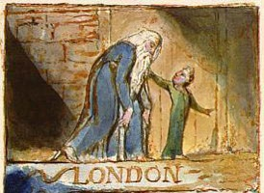 | The Soldier  England  Die  Concealed  Evil  Heaven  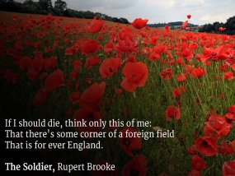 | She walks in Beauty  Night  Climes  Grace  Eloquent  Innocent  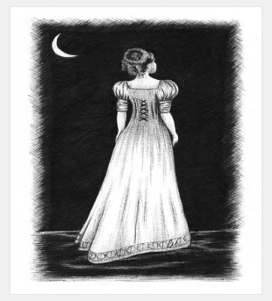 | Living Space  Crookedly  Dangerously  Slanted  Thin  Faith
As imperceptibly as Grief  Lapsed  Quietness  Dusk  Harrowing  Beautiful | Cozy Apologia  Anything  Free  Hurricane  Worthless  Bunkered | Valentine  Onion  Blind  Truthful  Fierce  Knife | A Wife in London  Tawny  Irony  Tragedy  thicker  flicker  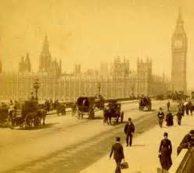 | Death of a Naturalist  Flax-dam  Slobber  Mammy  Chorus  Pulsed | Hawk Roosting  Sit  Hooked  Locked  Creation  Permitted
To Autumn  Maturing  Swell  Winnowing  Patient  Sing | Afternoons  Fading  Hollows  Wedding  Courting-places  Pushing | Dulce et Decorum Est  Beggars  Gas!  Drunk  Drowning  Incurable | Ozymandias  Traveller  Antique  Lifeless  King  Despair  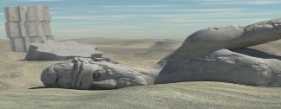 | Mametz Wood  Farmers  Wasted  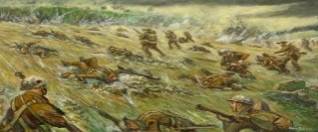  Broken  Nesting  Dropped | Excerpt from the Prelude  Frosty  Happy  Proud  Distant  Orange

