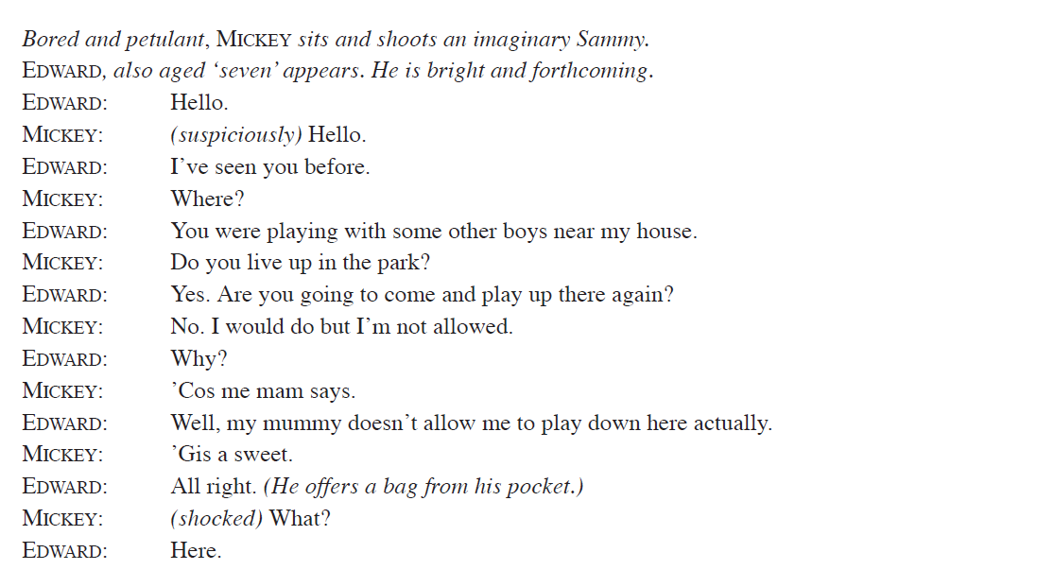

Example Extract/Essay:
Band 4  C+ - A-  7 - 5 | - Write in a detailed way with clear writing style that is appropriate for the task  - Write in a thoughtful way;  - Write with a secure understanding of key parts of the extract and the wider text, with a lot of engagement with various ideas;  - support and justify your responses with well-chosen direct reference to the extract and wider text, including quotations. | - You can discuss and will analyse writers’ use of language, form and structure;  - You can make thoughtful comments about the meanings and effects of stylistic features used by the writer;  Success Criteria  Use PEA  Include language techniques  Link to the extract  Explain what you think  Analyse the effect of the quote  Explore how it links to the wider text  Say what the writer’s intentions are  Develop your answer fully  - use good and relevant subject terminology.
The stage directions “(suspiciously)” when Mickey responds to Edward shows that Mickey is not used to people who are polite and friendly like Edward is. By using the adverb it shows that Mickey doesn’t trust people very much and perhaps this is because of his age, seven, or it could be due to the poor area that his family come from. Russell might be suggesting that the boys expectations of others are widely different, with Edward trusting and naive and Mickey suspicious and more street-wise. This links to the wider text when we find out about the way Sammy treats Mickey; nicking his sweets emphasises the way he has learnt not to trust people as his own brother treats him poorly. However, Edward as an only child has never had this relationship so trusts more easily.
How does the example above meet the success criteria?
Highlight and annotate where it meets this criteria.

Task 1: Read and do the peer assessment
Task 2: Create an extract – whole text (up to where you are in the book) analysis using the quote above and explore how Russell uses fate, superstition and foreshadowing to imply the boys meeting and becoming friends is inevitable

