Fan
Key facts

Pick three good words or phrases to describe the character:
description | quotation | explanation

change  poverty | the past  compassion | family  money and wealth
Themes:

Which themes are they linked to? | How?

Bob Cratchit
Key facts

Pick three good words or phrases to describe the character:
description | quotation | explanation

change  poverty | the past  compassion | family  money and wealth
Themes:

Which themes are they linked to? | How?
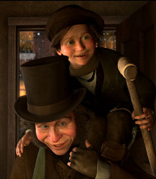
Tiny Tim
Key facts

Pick three good words or phrases to describe the character:
description | quotation | explanation

change  poverty | the past  compassion | family  money and wealth
Themes:

Which themes are they linked to? | How?

Mr Fezziwig
Key facts

Pick three good words or phrases to describe the character:
description | quotation | explanation

change  poverty | the past  compassion | family  money and wealth
Themes:

Which themes are they linked to? | How?

