A Christmas Carol – Stave Four Questions
- Describe the ghost of Christmas Yet to Come. What aspect of the Ghost’s behaviour scares Scrooge the most? (p.58)

- What evidence is there that Scrooge has accepted his need to change? (p. 58)

- Look back over the conversation between the business men at the beginning of the stave. How do they discuss the death of the un-named man? Hint: Look closely at the words used to describe how they are talking. (p. 59)

- Write down some details that are used to describe the streets that Scrooge and the Phantom travel through. What might this scenery suggest about Scrooge or his future? (p.61)

- What does the last lady remove from the room of the un-named corpse? What might be the significance of this? (p.63)

- Explain why the young man and his wife Caroline feel relieved that the unnamed businessman had died. What is Scrooge’s reaction to this scene? (p.66)

- List three details that alert you to the fact that Tiny Tim has died. (p.66-67)

- In what ways has Scrooge’s nephew shown “extraordinary kindness” to the Cratchit family? (p.68)

- Look again at the description of the graveyard. Why does Scrooge think that it is a “worthy place”? (p. 69)

- At the end of Stave Four, Scrooge pleads to learn whether he can alter the future that the Ghost has shown him. The Ghost does not answer in words, but gives a sign. Identify this sign, and explain what you think it means. (p. 70)
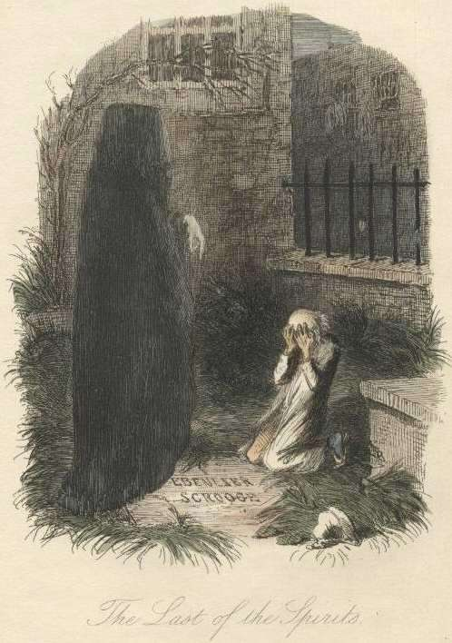
Aim Higher – Consider the writer’s viewpoints and intentions.
- Which figure might the Ghost remind you of? Dickens made this
link deliberately – why?
- The ghost doesn’t speak. What might this add to the atmosphere?
- The reader almost certainly realises the “dead man” is Scrooge. Why do you think Dickens makes Scrooge’s character realise this after the readers?

