Poetic device | Definition | Effect | Example
Alliteration  aaa | Repetition of initial consonant sounds in a group or words close together | Emphasises words and ideas, makes descriptions more vivid.  Unites words and concepts together. | “with her whole stripped skin  at her heel, stuck like an old  shoe sole or mermaid’s tail”  “Sudden successive flights of bullets streak the silence”
Assonance  aeiou | Repetition of a vowel sound | Helps create tone and affects rhythm, e.g. a, o, and u can slow down a line making it sound sad and weary and i can speed up a line. Gives a sense of continuity. | “it will creep into our dreams.”  “Keep your head down and stay in doors –  we’ve lost this war before it has begun.”
Consonance  bcfghj | Repetition of a consonant sound | Helps create tone and effect rhythm, e.g. ‘s’ sound is slow/soothing. | “innocent mice rejoice”  “the merciless iced east winds that knive us…”
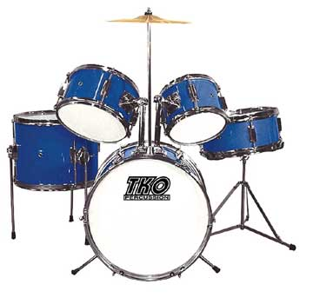  Onomatopoeia | The use of words which imitate sound | Emphasises words and ideas, makes descriptions more vivid. | “when miners roared past in lorries”  “I was trying to complete a sentence in my head but it kept  Stuttering”
Repetition | The purposeful re-use of words and phrases. | Reinforces words and ideas, makes them memorable and leaves a lasting impression. Makes poem more contained. | “I hate that drum’s discordant sound,  Parading round, and round, and round”  “Why did a great lord find me out  And praise my flaxen hair?  Why did a great lord find me out  To fill my heart with care?”
Rhyme | The use of words with matching sounds. Can be internal or at ends of lines. | Makes it memorable. Drives forward the rhythm. Unifies the poem and adds structure. | “O what is that light I see flashing so clear  Over the distance brightly, brightly?  Only the sun on their weapons, dear,  As they step lightly”
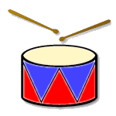  Rhythm | The pace or beat of the poem - can vary from line to line | Chosen to achieve a particular effect, e.g. to mirror pattern of natural speech or the pace of walking. May be fast, lively, slow, regular, irregular, awkward, tense, brisk, flowing, smooth | “I hate that drum’s discordant sound,  Parading round, and round, and round:”  “I remembered from my Sunday School book:  olive trees, a deep jade pool,  men resting in clusters after a long journey”
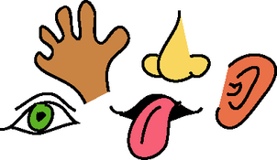  Imagery | Words that appeal to the senses | Creates vivid mental pictures and evokes ideas, feelings and atmosphere by appealing to the senses (sight, smell, taste, touch, and sound). | “On the river bank,  bees drizzle over  hot white rhododendrons”  “Sudden successive flights of bullets streak the silence.  Less deadly than the air that shudders black with snow,”
Simile  ‘like’ ‘as’ | A comparison between two unlike things using like or as. | Enhances descriptions, expands reader’s understanding of what poet is trying to convey, clarifies meanings. | “He wore me like a golden knot,  He changed me like a glove”  “their chanting foreign and familiar,  like the call and answer of road gangs”
Metaphor  ‘is’ | A comparison saying something is something else | Can uncover new and intriguing qualities of the original thing that we may not normally notice or even consider important. Helps us to realize a new and different meaning. Makes it more interesting to read. | “Suddenly as the riot squad moved in, it was raining  exclamation marks”  “I wrote  All over the walls with my  Words, coloured the clean squares”
Personification | Giving human qualities or characteristics to animals or inanimate objects | Makes the objects and their actions easier to visualize for a reader. Makes the poem more interesting and achieves a much more vivid image. | “Our brains ache, in the merciless iced east winds that knive us”  “I shall die, but that is all that I shall do for Death; I am  not on his pay-roll.”  “ the ansaphone kept screaming”
Symbolism | A word, phrase or image which stands for something. | Enables the writer to convey images directly to the mind of the reader - it serves almost like an emotional short-cut. | “So now I moan an unclean thing  Who might have been a dove”
Rhetorical question  ? | A question which does not expect an answer. | Plants a question in the reader’s mind and then guides them towards the answer they want them to reach. Makes a deeper impression upon the reader than a direct statement would. | “My name? Where am I coming from? Where am I going?”  “Why do you care what class I’m from?  Does it stick in your gullet like a sour plum?”
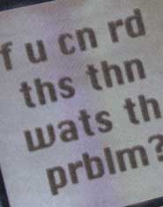  Colloquial language | Non-standard English, slang. | Makes it sound realistic, part of speaker’s identity, can indicate pride in roots, shows a relaxed and casual attitude. | “Ah lookin at yu wid de keen  half of mih eye”  “With an ‘Olly in me mouth  Down me nose, wear an ‘at not a scarf”  “Stitch that, I remember thinking”
Emotive language | Words and phrases that cause an emotional response in  the reader | Plays on the reader’s feelings, gets them to think or feel in a certain way according to poet’s intentions. | “And burning towns, and ruined swains,  And mangled limbs, and dying groans,  And widows’ tears, and orphans’ moans”  “these were not heroes in my town,  but maulers of children,  doing things that had to remain nameless.”
Free verse | Lines with no regular structure, rhyme or rhythm. | Allows for poet’s creativity. Can imply freedom, flexibility, and fluidity. Line lines may suggest excitement or a passionate outpouring; short lines break the flow and add emphasis. | “Excuse me  standing on one leg  I’m half-caste”  “Then my grandmother called from behind the front door,  her voice a stiff broom over the steps:  ‘Come inside; they do things to little girls.’”
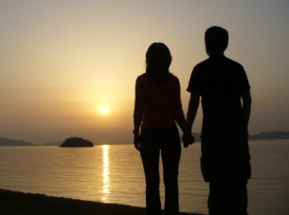  Couplet | A pair of lines, usually rhymed | Keeps a tight structure. Can help conclude a poem. | “Bread pudding is wet nelly  And me stomach is me belly”  “To thoughtless youth it pleasure yields,  And lures from cities and from fields”
Enjambment | A line ending in which the syntax, rhythm and thought are continued into the next line. | Draws the reader from line to line and verse to verse and makes poetry flow quicker by making it less blocky. Makes end rhymes more subtle. Can indicate excitement, anger or passion. | “I hear him leading his horse out of the stall; I hear  the clatter on the barn-floor.  He is in haste; he has business in Cuba, business in the  Balkans, many calls to make this morning.”  “the danger of the mission still around them  and night falling, its silver stars just like the ones  you got for remembering your Bible texts.”
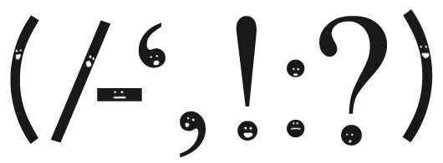  Caesura | A natural pause or break in a line of poetry indicated by punctuation | Stops rhythm becoming predictable. Mirrors natural speech. Lots of pauses slow the pace of the poem. May make you pause abruptly, drawing attention to that idea. | “Slowly our ghosts drag home: glimpsing the sunk fires, glozed  With crusted dark-red jewels; crickets jingle there”  “Why can’t I escape? Every move is punctuated. Crimea  Street. Dead end again.”  “No change. My Dad did. What? What did his Dad?”

