Mini Guide for The Anthology @Eduqas MT:Main Themes C:Context M:Meaning Q:Quotes BL:Best links
The Manhunt- Armitage  MT:War,Suffering, Love&Relationships,  C: Peacekeeper in Bosnia, Shot, PTSD, Eddie and Wife rebuilding relationship  M: Physical and emotional pain, wife supporting him towards recovery and carefully exploring the physical injuries, but then identifying the root of problems are in his mind - the horrors of war that he endured and being shot.  Q: “Frozen river which ran through his face”  “handle and hold”  “Feel the hurt of his grazed heart”  “Foetus of metal beneath his chest”  “Unexploded mine buried deep in his mind”  “Only then did I come close”  BL: Dulce, Wife in London | Sonnet 43 -Browning  MT:Love&Relationships  C: Romantic poets influence, Wrote 44 sonnets (love poems) to husband before marriage, Parents difficult, An invalid in early years – poetry was escape. Religious upbringing.  M: Intense nature of her love for her husband to be. She outlines all the different ways she loves him.  Q:”How do I love thee? Let me count the ways.”  “..to the level of every day’s most quiet need”  “..with my childhood’s faith”  “…with the breath, smiles, tears of all my life”  “…better after death”  BL: Cozy Apologia, Valentine | London - Blake  MT: Suffering, Place, Childhood  C: Terrible poverty, Anti-religion-Church did nothing to help, child labour/prostitution, Blake believed in spirit of French Revolution(1790s) –should be action against harsh government, Blake lived in London in the Georgian Era ( –saw it all.  M: Widespread suffering of the poor in bleak London. There is deep suffering in adults who cry and die young, and in children who are forced to work dangerous jobs, even prostitution. The government and the church are blamed.  Q: “Marks of weakness, marks of woe”  “Mind forged manacles”  “Every black’ning church appals”  “The youthful harlot’s curse”  “The marriage hearse”  BL: Living Space, Afternoons,, Dulce  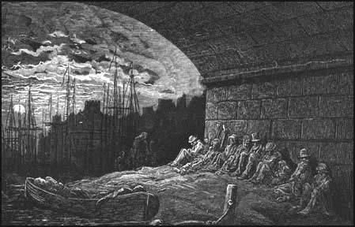 | The Soldier - Brooke  MT: War, Death  C: Written BEFORE war started, originally entitled ‘The recruit’, Propaganda, 2 million men ended up dying in WW1.  M: Men owe it to their country to fight. If they die, their remains will proudly represent English territory abroad, and their soul will go to a special English heaven where friends, and fun will return.  Q: “There’s some corner of a foreign field that is forever England”  “A dust whom England bore, shaped, made aware”  “Gives somewhere back the thoughts by England given”  “At peace under an English heaven”  BL:, Dulce, | She walks in Beauty -Byron  MT: Beauty, Women, Love&Relationships  C: Written about his cousin’s wife who was in a black dress at a funeral –struck by contrast between striking youthful beauty and dark clothing,  One of the Romantics – believed in passion/beauty,  Wild, many affairs, womaniser  M: Exploration of both outward, physical beauty, and inner beauty: the mind at peace, and an innocent heart.  Q: “She walks in beauty like the night of cloudless climes and starry skies”  “All that’s best of dark and bright meet in her eyes”  “How pure, how dear their dwelling place”  “A heart whose love is innocent”  BL: Sonnet 43, Cozy Apologia, Afternoons, | Living Space -Dharker  MT: Place  C: Poet divides time between London and India, A film maker who wanted to raise awareness of issues like terrible conditions of Mumbai slums  Poet recognises courage of Mumbai slums residents who have purposefully moved to the city to try and improve life chances  M: Both concerned and awe-struck by the dangerous living conditions and fragile housing structures. Admires their courage and hope against the odds.  Q: “Nails clutch at open seams”  “The whole structure leans dangerously towards the miraculous”  “Someone has squeezed a living space”  “As if they were the bright thin walls of faith”  BL: London, A Wife in London,
As imperceptibly as Grief - Dickinson  MT: Nature, Death, Change, Suffering, Love & Relationships  C: Poet was a recluse –hardly ever saw people, poem thought to be written about either the departure/death of a friend who had been staying, or  perhaps unreciprocated love. Grew up in New England countryside – beautiful place in America. Inspired by Romantics –saw the beauty in nature. 5 of her school friends died of T.B.  M: The summer passes too quickly for her liking and as her friend leaves/dies? She notices the darker side of nature approaching, and feels lost.  Q: “The summer lapsed away”  “A quietness distilled as twilight long begun”  “The morning foreign shone”  “As guest that would be gone”  “Without a wing or service of a keel”  BL: To Autumn, Wife in London,  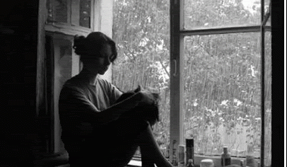 | Cozy Apologia - Dove  MT: Love & Relationships, Power  C: Poet married to fellow writer, Fred Viebahn –a tribute to him.  Poem is set against the imminent arrival of Hurricane Katrina where 6000 people lost their homes.  M: She is distracted from her writing by her powerful love for her husband who is also writing in the room, whilst Hurricane Katrina approaches. Husband is portrayed as knight in shining armour, better than teenage crushes, and she feels safe and protected when she’s near him. She believes it is a bit clichéd but the relationship makes her happy.  Q: “I could choose any hero, any cause, any age and sure as shooting arrows to the heart...there you’ll be”  “One eyes smiling, the other firm upon the enemy”  “A hurricane is nudging up the coast. Oddly male: Big Bad Floyd”  “Teenage crushes on worthless boys”  “When has the ordinary ever been news?”  “To keep me from melancholy, I fill this stolen time with you”  BL: Sonnet 43, Valentine, | Valentine - Duffy  MT: Love & Relationships, Power  C: Poet Laureate. Famous for beautiful and subversive love poems. As a feminist and a lesbian, she may have been seeking to challenge traditional, stereotypical views of love in society. A strong woman giving the gift in the poem, not a man who was originally expected to buy valentine gifts like roses.  Dad was a Labour party candidate –inspired Duffy to criticise materialistic Thatcherite society. Lays bare the fake, clichéd, consumerist Valentine’s day institution.  M: Rather than clichéd gifts like cards, roses, etc, the speaker gives her lover an onion which she believes is a real, genuine gift of love. It acts as a powerful extended metaphor for all the different things love represents: its power and hold over someone.  Q: “Not a red rose or a satin heart. I give you an onion.”  “It is a moon wrapped in brown paper”  “It will blind you with tears”  “Its fierce kiss will stay on your lips –possessive and faithful”  “Its platinum loops shrink to a wedding ring”  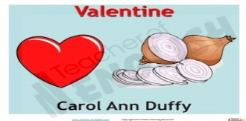  “Its scent will cling to your fingers, cling to your knife”  BL: Cozy Apologia, Sonnet 43, | A Wife in London -Hardy  MT: Love, Death, War, Women, Place  C: About the Boer War, and a soldier’s death. Communication channels bad in 19th century. Poet concerned with plight of single women. Poet was separated from wife; wife died; he still loved her though and read over her letters after she died –which links to the voice from beyond the grave idea.  M: In the thick, gloomy London fog, a wife waits alone, separated from her husband who has gone to fight. A messenger delivers a telegram which informs her that her husband has died in battle. The shock is huge. The irony is that the next day a letter is delivered from her husband which talked of all his plans for them on his return.  Q: “She sits in the tawny vapour that the City lanes have uprolled”  “A messenger’s knock cracks smartly”  “Shaped so shortly: He – has fallen – in the far South Land.”  “His hand, whom the worm now knows”  “Penned in highest feather -page full of his hoped return”  BL: As imperceptibly as grief, Living Space, The Manhunt  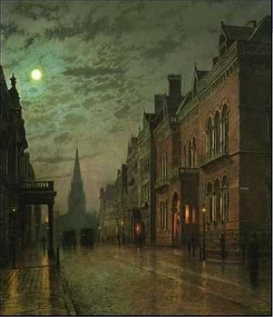 | Death of a Naturalist -Heaney  MT: Nature, Place, Childhood, Change  C: Reflects the poet’s interest in nature. Reflects the loss of his childhood innocence and naivety. Age 12 –his brother died.Perhaps references the fear of his maturing sexuality, as he started a Catholic boarding school where sinful deeds were punished, and attitudes to sex were very strict.  M: A boy visits a swamp and takes some frogspawn to observe at home. He is fascinated to learn about them.  A second visit when he is older has different results – the frogs appear menacing and vengeful.  Q: “Best of all was the thick warm slobber of frogspawn”  “Wait and watch until the fattening dots burst into nimble swimming tadpoles”  “Miss Walls would tell us how the daddy frog was called a bullfrog”  ”A coarse croaking I had not heard before”  “Some sat poised like mud grenades”  “The great slime kings were gathered there for vengeance”  BL: The Prelude, Hawk Roosting, To Autumn | Hawk Roosting -Hughes  MT: Nature, Power, Death  C: Hughes fascinated by animals, was a farmer for a short while. Studied Anthropology – the behaviour of humans within past and present societies.  Hawk was a Nazi symbol, and politicians are described as ‘hawkish’ –aggressive towards other countries. Hughes probably used the hawk as a metaphor for the way some leaders arrogantly abuse their power like Hitler.  Do humans just act on animal-instincts? Anti-religion too possibly.  M: The hawk, a predatory bird, surveys its kingdom, believing Nature looks to it for approval.  It is in awe of its creation, and kills brutally and indiscriminately, taking notice of no-one. It has always been this way in nature and the Hawk does not want it to change.  Q: “Earth’s face upward for my inspection”  “I hold creation in my foot”  “My manners are tearing off heads”  “No arguments assert my right”  “Nothing has changed since I began. My eye has permitted no change”  BL: Ozymandias, Death of a Naturalist
To Autumn -Keats  MT: Nature, Death, Beauty, Change  C: Dying of T.B. and had seen many of his friends and family die. Realised accepting our own mortality doesn’t mean we can’t see the beauty in things.  One of the Romantics – A believer in beauty and truth.  Poet uses the form of an ode (one he used a lot) where he personifies and addresses Autumn directly.  M: The speaker admires the busy activity of End Summer/Early Autumn where fruit is ripening. In Stanza 2, the personified Autumn rests after the harvest work, and things slow down. Stanza 3 looks at the dying of Autumn and imminent winter, praising its beauty that few notice.  Q: “Close-bosom friend of the maturing sun, conspiring with him how to load and bless”  “Overbrimmed their clammy cells”  “Sitting careless on a granary floor, thy hair soft-lifted by the winnowing wind”  “Thou watches the last oozings hours by hours”  “Where are the songs of Spring?’  ‘Thou hast thy beauty too”  BL: As imperceptibly as grief, Death of a Naturalist, Afternoons | Afternoons -Larkin  MT: Women, Change, Love&Relationships, Place, Childhood  C: Poet liked to observe others from a distance.Was cynical towards family life. He never married and disliked children, saying they ‘diluted’ a person.  Poet’s mum and dad were not in a happy, loving marriage. Terrified by the passing of time, and way your life races away.  M: Mothers gather in a playground watching their children play. The women used to be the ones that were lovers and lead exciting lives, but now theirs is a life of domestic drudgery: washing, ironing, whilst their husbands get to pursue ‘skilled’ jobs. There is little regard for their relationship any more as the wedding album is discarded. The women’s beauty has faded, and the children have replaced them in importance.  Q: “Hollows of afternoons”  “Setting free their children”  “The albums lettered Our Wedding, lying”  “The lovers are all in school”  “Their beauty has thickened”  “Something is pushing them to the side of their own lives”  BL: She walks in beauty, To Autumn, | 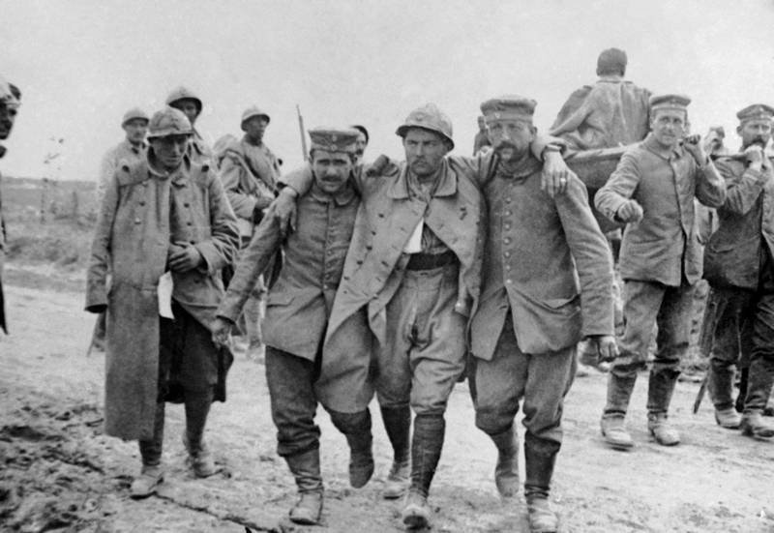  Dulce et Decorum Est -Owen  MT: War, Suffering, Death  C: ‘Dulce…” title is Latin for ‘It is sweet and fitting to die for one’s country’ –a phrase used as propaganda to persuade men to sign up to fight. Owen who experienced the horrors of WW1 first hand believed it to be a LIE! The poem is a direct challenge to writers who were glamourising the war such as Owen Seaman who never actually fought in the war. War challenged the poet’s Christian beliefs.  The use of mustard gas referred to was a chemical that led to an agonising death, and was first used by the German army in 1917.  M: The soldiers are utterly exhausted, and described like old beggars and hags. Suddenly there is a gas attack and one poor soldier cannot get his mask on in time. The speaker is helpless and has to watch him die an agonising death in front of him. The poet asks how anyone who witnessed what he did can continue to tell the old lie about it being a good thing to die for your country.  Q: “Like old beggars under sacks, coughing like hags”  “Gas! Gas quick boys!”  “He plunges at me, guttering, choking, drowning”  “Obscene as cancer”  “His hanging face, like a devil’s sick of sin”  “My friend, you would not tell with such high zest”  BL: London, Mametz Wood, The Manhunt | 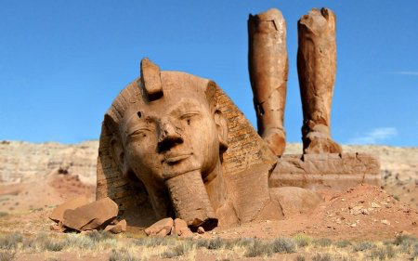  Ozymandias - Shelley  MT: Power, Death, Change  C: Poet inspired to write poem when he heard British Museum secured large fragment of the statue of the Egyptian Pharoah Ramesses II.  Shelley’s wife, Mary Shelley ,was the author of Frankenstein, and was fascinated by the science of the time that was obsessed with living on after death.  Written as warning to rulers who get too powerful and believe they are invincible. He hated Royalty. One of the ‘Romantics’ –he believed nature would always be more powerful than mankind.  M: The speaker recalls a conversation with a traveller who tells him about a broken statue he saw lying in pieces in the desert. The face has a sneer, it is implied he was mostly cruel, and the writing on the base of the monument boasts of Ozymandias’ name and his works. His powerful status, and the boasts/ hopes of being remembered are almost laughable, as nature has eroded and damaged the statue over time beyond repair.  Q: “Two vast and trunkless legs of stone stand in the desert.”  “The sneer of cold command tell that its sculptor well those passions read”  “The hand that mocked them, and the heart that fed”  “ My name is Ozymandia, king of kings, Look on my works, ye Mighty and despair!”  “Nothing beside remains round the decay of that colossal wreck.”  BL: Hawk Roosting, The Soldier | Mametz Wood -Sheers  MT: War, Death,  C: Battle of the Somme –bloodiest battle of WW1. Welsh division ordered to take Mametz Wood – much bigger undertaking that generals thought. 600 died, 4000 injured.  They succeeded but bravery wasn’t acknowledged at the time. Poet grew up in Wales -fascinated by history and identity of Welsh people.  The ‘Dance Macabre’ (Skeleton leading people by the hand to their death) is an image from medieval poetry and art, symbolising inevitability of death for all, and the need to consider the state of our souls.  M: Farmers find the broken bones of the soldiers’ bodies for years afterwards. We learn the soldiers courageously walked together as a unit towards machine gun fire that ripped many of them in half.  As the men are found, it is almost like their voices are heard again, and we remember their sacrifice.  Q: “For years afterwards the farmers found them -the wasted young”  “The broken bird’s egg of a skull”  “Twenty men buried in one long grave”  “Their skeletons paused mid dance macabre”  “In boots that outlasted them”  “As if the notes they had sung have only now, with this unearthing, slipped from their absent tongues”  BL: The Manhunt, Dulce | Excerpt from the Prelude - Wordsworth  MT: Childhood, Change, Nature, Place,  C: Poet grew up in beautiful Lake District where poem is set.  One of the ‘Romantics’ –believed in beauty and nature, and moments that transcend reality.  Poet’s mother died when he was 8. Father died at 13. Poem depicts a happier time when parents were alive.  M: The speaker nostalgically recalls a happy time in his youth when he played with friends, skating on the frozen lakes with the mountains behind. They felt animal like in their freedom. The tinkle of the ice skates on the ice though suddenly echoes around the mountains and the sound is eerie, unnerving and somehow sad, perhaps representing the end of the evening, and maybe his youth, as the darkness draws in.  Q: “I heeded not the summons: -happy time”  “I wheel’d about, proud and exulting, like an untired horse”  “We hissed along the polished ice in games confederate”  “Every icy crag tinkled like iron”  “An alien sound of melancholy”  “The orange sky of evening died away”  BL: Death of a Naturalist, To Autumn,

