- Editing challenge – CHANGE THESE!
- Plath’s feelings on this when trying to write this may have been that the a child is held highly esteemed in mothers perspective and are well cherished.

- She has pride for what her child mayt become ‘my little loaf’. Almost as if it is a bread winner.

- Another reason why they “watch” from the line “Love set you going like a fat gold watch’ could be a metaphor for a watch is because a watch is something which you see as it changes over time –as is a baby.

- This suggests that history has taken place when it is born such a powerful thing. And they all stand in awe.

Lack of Editing = U grade if lines like these pop up too much!!

- Introduction Challenge
What makes a good introduction?

- Signify Switches of poet / poem clearly
- Don’t do the minimum! – 2 pages of hand written would simply not be enough in the exam, so why do it in practice?

- The three ‘Step-Out’ Models

- Not at all (E/N)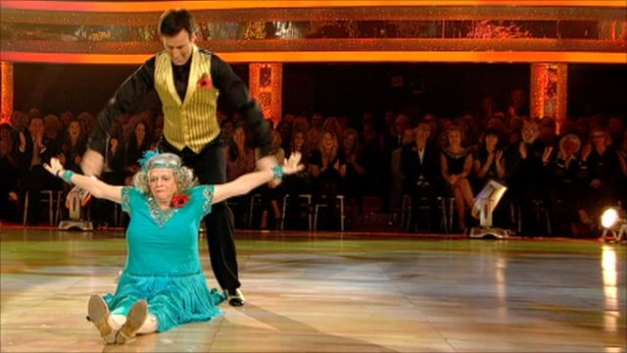
The narrator is anxious when her child is born, evident in the line “I’m no more your mother”. Here the narrator feels distant from her child, and that it is not natural. Also this point is further emphasised as the child is described by the narrator as a “New Statue” which implies how the baby is something strange, and cold, but perhaps the narrator also feels it is something to be adored and worshipped.

- Tagged on at the end (D/C)
The narrator is anxious when her child is born, evident in the line “I’m no more your mother”. Here the narrator feels distant from her child, and that it is not natural. Also this point is further emphasised as the child is described by the narrator as a “New Statue” which implies how the baby is something strange, and cold. Plath clearly feels childhood is a difficult experience, and it is hard for women to develop a bond quickly with their child. Plath could also be saying the child is something to be adored and worshipped.

- Leading with the step! (B-A*)
Plath presents a sense of anxiety when children are born, evident in the line “I’m no more your mother”. Here the narrator feels distant from her child, and Plath conveys the way mothers can often initially struggle to embrace the maternal role. Also this point is further emphasised as Plath describes the child as a “New Statue” which implies how the baby is also seen as something strange, and cold, however some readers may argue it is something to be adored and worshipped.

N.B - If there is no ‘I’ in the poem, you can probably get away with assuming it is the poet’s views.
e.g. Manor Garden, You’re, Munich Mannequins and lots more!

