Component One Narrative writing guide
In the Exam Section B you will be given a choice of four titles, which should link to something in your own experience:
For Example:
An unexpected visitor
Or
A trip to the zoo
Or
A special day
Or
Write a story which begins:
“I knew it was a bad idea, but...”

WORD LIMIT – 450 words to 600 words
Why is it important?
20% of component one of your exam
20% of your overall GCSE – worth 40 marks
Timing 1 hour in total:
5 minutes planning
55 minutes writing

WHAT IS IMPORTANT IN THE STORY?
Communication and organisation | Vocabulary, sentence structure, spelling and punctuation.
- I should be able to use paragraphs  - I should be able to vary the length of my paragraphs  - I should be able to change the way I open my paragraphs  - I should be using Tiptop to change paragraphs when required – Time, Place, Topic & Person = new paragraph  - I should be able to write sentences which are clear and make sense  - I should be able to use simple, compound and complex sentences  - I should be aware of how to use sentences to create tension  - I should be able to hold information back from the readers, so that they want to keep reading  - I should be able to describe character in detail to interest my reader  - I should use setting to create a sense of place and interest  - I should be able to hook the reader into my story and make them want to enjoy what happens  - My plot should be believable and interesting | - I should be able to use a variety of interesting words, phrases and techniques in my writing to create an effect  - Adjectives to describe  - Adverbs to say how something is being done in my story  - Extended noun phrases to develop the detail in my description  - Metaphors, similes and personification to create imagery  - I should be able to use full stops correctly  - I should always use capital letters for the start of my sentences and for the names of people and proper nouns – people and places  - I should always use commas in lists  - I should always use commas when I use an introductory phrase in a sentence or a connective to start a sentence or an adverb which starts a sentence  - I should always use commas to separate clauses in complex sentences  - I should always use an apostrophe to show possession – James’ bag  - I should always use an apostrophe in contractions – do not = don’t  - I should attempt to use colons and semi-colons  - I should also use question marks to show that a question is being asked  - I should use an exclamation mark to show surprise  - I should learn spellings of commonly misspelled words  - If I am unsure of a spelling I know how to use a dictionary and will get one to search for the word  - I should always remember to check my work for COPS – Capitals, Ommisions (words left out of a sentence), punctuation and sentence structures  - I should stay in the same tense – past tense  - I should write in the same person, first, second or third
 | AO5 Communication and organisation 24 marks | AO6 Vocabulary, sentence structure, spelling and punctuation 16 marks
Band 5 | 20-24 marks  - the writing is fully coherent and controlled (plot and characterisation are developed with detail, originality and imagination)  - the writing is clearly and imaginatively organised (narrative is sophisticated and fully engages the reader’s interest)  - structure and grammatical features are used ambitiously to give the writing cohesion and coherence  - communication is ambitious and consistently conveys precise meaning | 14-16 marks  - there is appropriate and effective variation of sentence structures  - virtually all sentence construction is controlled and accurate  - a range of punctuation is used confidently and accurately  - virtually all spelling, including that of complex irregular words, is correct  - control of tense and agreement is totally secure  - a wide range of appropriate, ambitious vocabulary is used to create effect or convey precise meaning
Band 4 | 15-19 marks  - the writing is clearly controlled and coherent (plot and characterisation show convincing detail and some originality and imagination )  - the writing is clearly organised (narrative is purposefully shaped and developed)  - structure and grammatical features are used accurately to support cohesion and coherence  - communication shows some ambition and conveys precise meaning | 11-13 marks  - sentence structure is varied to achieve particular effects  - control of sentence construction is secure  - a range of punctuation is used accurately  - spelling, including that of irregular words, is secure  - control of tense and agreement is secure vocabulary is ambitious and used with precision
Band 3 | 10-14 marks  - the writing is mostly controlled and coherent (plot and characterisation show some detail and development)  - the writing is organised (narrative has shape and direction)  - structure and grammatical features are used with some accuracy to convey meaning  - communication is clear but limited in ambition | 7-10 marks  - there is variety in sentence structure  - control of sentence construction is mostly secure  - a range of punctuation is used, mostly accurately  - most spelling, including that of irregular words, is correct  - control of tense and agreement is mostly secure  - vocabulary is beginning to develop and is used with some precision
Band | 5-9 marks  - there is some control and coherence (some control of plot and characterisation)  - there is some organisation (narrative is beginning to have some shape and development)  - structure and grammatical features are used to convey meaning  - communication is limited but clear | 4-6 marks  - some variety of sentence structure  - there is some control of sentence construction  - some control of a range of punctuation  - the spelling is usually accurate  - control of tense and agreement is generally secure  - there is some range of vocabulary
Band 1 | 1-4 marks  - there is basic control and coherence (a basic sense of plot and characterisation) there is basic organisation (paragraphs may be used to show obvious divisions)  - there is some use of structure and grammatical features to convey meaning  - communication is limited but some meaning is conveyed | 1-3 marks  - limited range of sentence structure  - control of sentence construction is limited  - there is some attempt to use punctuation  - some spelling is accurate  - control of tense and agreement is limited  - limited range of vocabulary
 | 0 marks: nothing worthy of credit | 0 marks: nothing worthy of credit

How can I plan effectively?
You could create a quick chart
Or, split it into the different stages of the story
Or, mind map
Or, bullet point list
5 W’s – Who, what, where, why & when
Planning
Intro
Rising Action
Climax
Falling Action
Ending/Resolution
Story Mountain

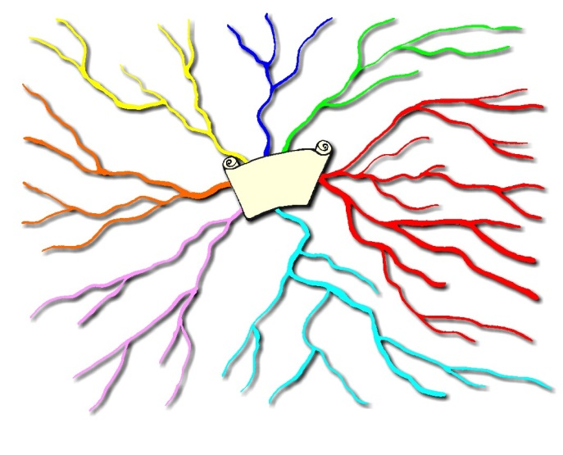
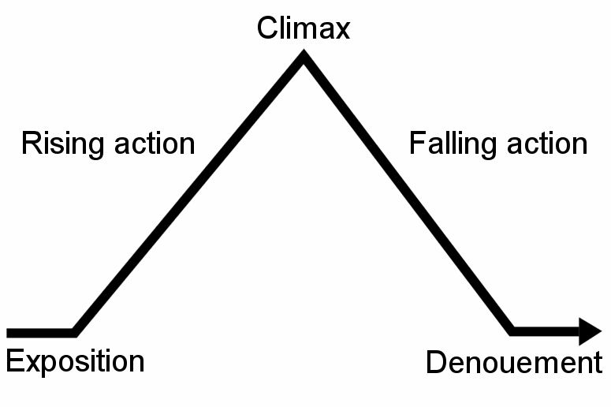

Some Examples of openings

What is good about these?

How could they be improved?

“Stop! You’re going to get hurt!” screamed Mark as the path began to disappear and the moon fell menacingly behind a cloud…

I didn’t listen to Mark that day but I wish I had. Mark was a good friend of mine and..

Kate needed the special perfume case or her life would not be worth living. Terror ran through her veins as she imagined her mum’s reaction to what she was going to tell her…

Kate’s Mum, Lisa had always been in to her make-up…

Reflecting back on events and Witholding Information

It happened a while ago. Everyone has forgotten, they think I have too. I haven’t. I couldn’t. It is impossible when it’s all I dream about and everything that I see reminds me. Most people have moved on. I pretend I have too- but I can’t. It just won’t go away however hard I try to think about something else. You hear about it all the time but you never expect it happen to you and your family.

It was a strange day in _________

I never thought I was going to get so near –so close to the prize I could smell it. All my life I had waited for such a moment, but when it came down to it, I knew I always went to pieces at important times in my life.

Singing had always been part of my life from _________

Titles to practice
The Adventure | An Impossible task | The seaside
Best Day Ever | When I was young | Happy dreams
My Family | The Impossible | Holiday happiness
Growing up | Holiday from Hell | A dream come true
My worst experience | My best experience | Primary School
My first day at Secondary School | Brothers and sisters | Story starting with:  “It was cold and quiet…
Story starting with:  “The night seemed to be never-ending” | Story starting with:  “I was so happy to be there…” | Story starting with:  “If only I had known…”
:
Planning space:

