A Christmas Carol – Stave 1 –Plot Questions

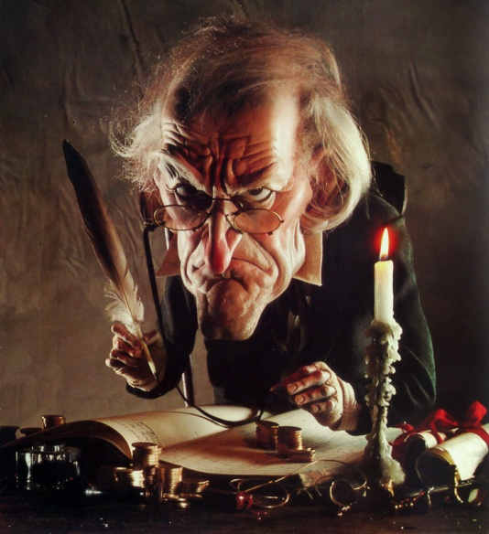
- Why do you think the narrator talks to the reader? What type of storytelling is Dickens trying to achieve by this style of writing?

- Who is dead and what is his association with Scrooge? (P.7)

- Identify two images to describe Scrooge’s physical appearance(top of P.8) and explain why you think they are used.

- How do other people treat Scrooge? (P.8)

- Identify two ways Bob Cratchit’s working conditions are poor. (P.9)

- Who tries to get Scrooge to visit for Christmas? (P.9)

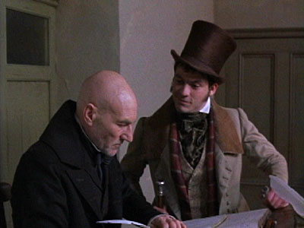
- What kind of character is the answer to question 6?

- How does Scrooge react to mentions of Christmas? (P.10/11)

- Who comes to visit Scrooge next and what do they want Scrooge to do? (P.12)

- Find a line to show Scrooge’s uncharitable response. (P.12)

- What does Scrooge whinge about on page 14?

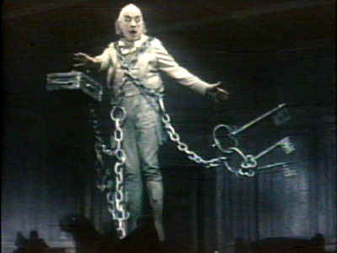
- Where does Scrooge live and what is significant about the location of his ‘home’? (P.14)

- Which ghost first appears to Scrooge and what might be symbolic about the fact he has to drag around a chain that he “forged in life. I made it link by link.”

- Explain one thing the ghost is unhappy about. (P.20)

- What does the ghost tell Scrooge to expect and what does Scrooge see when he looks out of the window? P.21/22

