A Christmas Carol –Stave 2-Questions

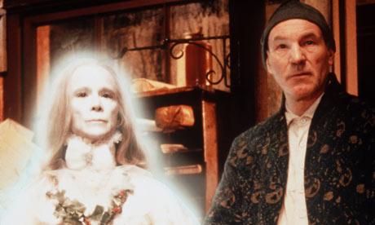
- Write down two details about the Ghost of Christmas Past’s appearance. (P.24)
- What is symbolic about the light that comes from the Ghost’s head? (P.25)
- How has Scrooge been neglected at Christmas time by his family? (P.27)
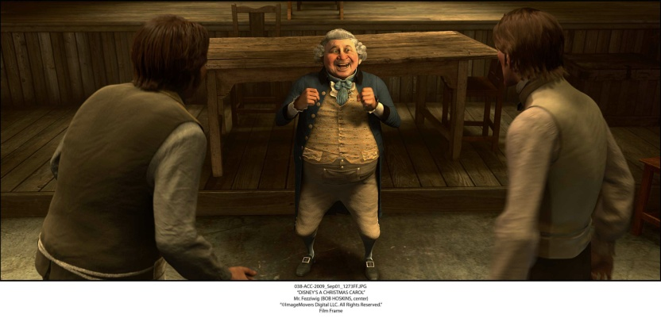
- In the second Christmas scene, Scrooge is a little older. What kind of character is Fan? What relation is she to Scrooge? (P.29)
- Who is Mr Fezziwig, and what kind of character is he? Use two quotes to support your answer (P.31/32)
- How does Scrooge react watching the Fezziwig scene, and who does he think of immediately after, and why? (P.33)
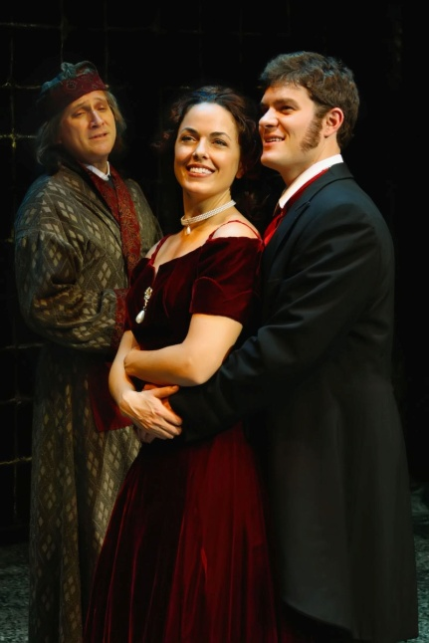
- Who was Belle, and why does she leave Scrooge?
- In the final scene, who is featured, and why is it unbearable for Scrooge?

A Christmas Carol –Stave 3 –Questions

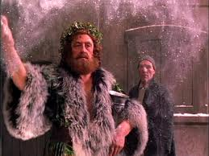
- Write down two details about the Ghost of Christmas Present’s appearance. (P.39/40)
- How is Scrooge’s attitude towards the ghosts changing? (P.40)
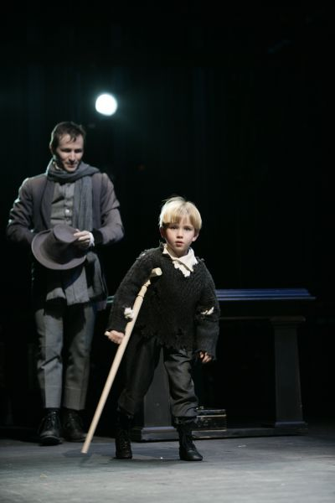
- Write down two quotes that are used to describe the food being prepared on Christmas morning. Why do you think the Ghost of Christmas Present shows Scrooge this? (P.41/42)
- What type of people does the Ghost point out to Scrooge in the second half of page 42 and why does the Ghost sprinkle drops of water on their plates?
- What is the moral lesson on page 43 that the Ghost teaches Scrooge?*
*=Hard question!!
6) What does Bob Cratchit recall that his son, Tiny Tim says at Church that day, and what do we learn about his character as a result? (P.45)
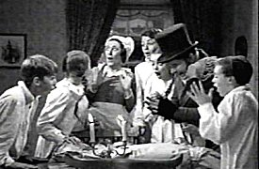
7) Write down a line to show the mood in the Cratchit house on Xmas day. How might you describe it? (P.46)
8) Is there any evidence to hint that the Cratchits actually haven’t got that much food on Xmas day? (P.46)*
* =Hard question!
9) What do we learn may happen to Tiny Tim in the future according to the ghost and how do Scrooge’s words come back to haunt him? (P.47)
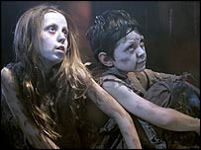
10) How does Bob Cratchit feel about his boss Scrooge on Christmas day, despite the way he is often treated? (P.48)
11) What scene does Scrooge get shown in the final part of this scene? (P.52-55) and what do the characters say about him?
12) Where does the Spirit take Scrooge next at the top of P.56?
13) Who are the terrifying figures at the end of the chapter and what do they represent? (P.56/57)

